## Lab 3-07: Downloading IAM Credential Report from Console

### Service Introduction

Downloading an IAM (Identity and Access Management) Credential Report from the AWS Management Console involves accessing the IAM service within the console, navigating to the Credential Report section, and initiating the report generation process. Accessing this report is crucial for security audits, ensuring adherence to best practices, and monitoring IAM users' usage and health and associated access keys within an AWS account.

### Problem

You are in a software house with 500 employees using the same AWS account. You want to audit each account to see the password policies and when they were last used. You want to know whether the MFA is activated or not. How can you know about each account PR when there are many users in a company?

### Solution

We will generate and download a credential report with one click that lists all the AWS accounts of the organization. It will show the terms of the password and when the password was enabled when it was last used or changed. Similar to the access keys, whether it is active or not.

Follow the given steps to download the Credential Report from the AWS Console.

1. Log in to the AWS Console.

2. Click on ‘Services.’



3. Select ‘IAM’ from ‘Security, Identity & Compliance’.



4. You will see ‘Credential Report’ in ‘Access Reports’.



5. Click on the ‘Download Report’ button.



6. It will download the CSV file, where you will be able to see all the information.

## Lab 3-08: Create CloudFront Distribution for Large Files

### Lab Prerequisites

* Familiarity with basic AWS Cloud Computing concepts and terminology
* An AWS account with an active subscription

### Service Introduction

Amazon CloudFront is a global Content Delivery Network (CDN) service that securely delivers data, videos, applications, and APIs to end-users with low latency and high transfer speeds. Amazon CloudFront can deliver an entire website, including dynamic, static, streaming, and interactive content, through a worldwide network of data centers called Edge Locations. When a user requests content, it is automatically routed to the nearest edge location with the lowest latency to deliver content with the best possible performance.

A CDN is a network or system of distributed servers that deliver webpages and other web content to end-users based on the user's geographic location, the origin of the web page, and a content delivery server using edge locations.

**Origin:** The source of the files that the CDN will deliver is called the origin. An S3 bucket, an EC2 instance, an Elastic load balancer, or Route53 can all be used.

**Distribution:** The name given to the CDN, consisting of a collection of edge locations, is called distribution.

### Case Study Enterprise Retail – Primooz

Background

Primooz was established in the year 2010 by a group of investors in the United Kingdom. The company started selling high-quality foods, medicines, beverages, and fashion products in the United Kingdom. It has grown to become one of the most popular UK online shopping stores, gaining goodwill from shoppers due to its memorable in-store experience.

Primooz offices, manufacturing plants, data centers, and employees are based in the following locations:

* **Head Office in London:** Approximately 100 employees are based at the head office involving strategy, marketing, finance, human resources, technology, and operations
* **Regional Offices:** 3 Regional offices are in Manchester, Liverpool, and Leeds. Each office consists of 5 to 10 employees from Sales and Pre-Sales functions
* **Manufacturing Plants:** 2 Manufacturing plants are based in Liverpool and Shanghai, China
* **Data centers:** Primooz has only one data centre in London with 20 x 42U rack space
* **Remote Workforce:** Around 50 sales representatives are hired across the UK to boost sales

Business Challenge

Primooz development team is working on a new project where high-quality images are uploaded to a shared online repository. The development team from regional offices frequently accesses these large images. The repository is hosted in London data centers, and users in the Manchester and Liverpool offices complain about the slow loading of images. Also, frequent download of these large images consumes a lot of bandwidth at the London data center. You are hired as a consultant by Primooz to look into this issue for a better user experience.

Proposed Solution

After the initial analysis, you have concluded that the slow loading of images for the regional offices is due to their geographical location. By distributing content closer to Manchester and Liverpool, visitors will experience faster page loading times. You have decided to enable the Amazon CloudFront services, decreasing the loading time for remote users and saving the bandwidth at Origin servers.

Lab Diagram

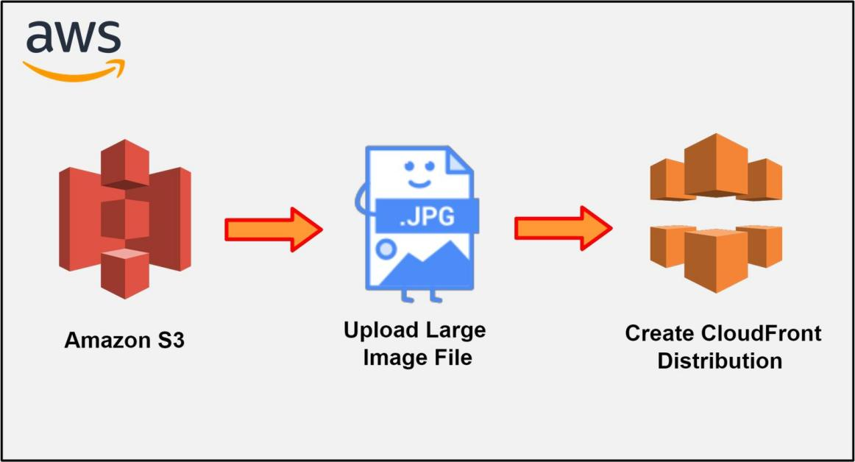

Figure 3-12: CloudFront Distribution for Large Files

Implementation Steps

1. Create the S3 Bucket.
2. Upload a large Image File.
3. Create CloudFront Distribution.

### Solution

|  |
| --- |
| **Step 1: Create the S3 Bucket**   1. Log in to the **AWS Console**. 2. Click on **Services**.      1. Select **S3** from the storage list.      1. Click on the **Create Bucket** button.      1. After entering the **DNS unique name,** select the **region**. 2. Enter **aws-retailer-website** as **Bucket name** and Select **US East (N. Virginia)** as **AWS Region**.      1. Now, uncheck **Block *all* public access**. 2. Select **Create bucket**.      1. You will see **aws-retailer-website bucket** has been **successfully created**.     **Step 2: Upload a Large Image File**   1. Once a bucket is created, you will need to **upload a file** that will be accessed through **CloudFront** instantly. 2. Click on the newly created **aws-retailer-website bucket** to **upload a file**. 3. Click on **Upload**.      1. Here, you are uploading an **e-shop.jpg** image file. 2. After uploading files, click on **Upload**.      1. Here, you will notice the image file is larger. 2. It may take some time to upload, depending on the region and size of the file.      1. Once the file **e-shop.jpg** is uploaded, you need to make it public, so it can be accessed. 2. Select the image file, click **Actions,** and select **Make public via ACL**.      1. Now, click on **Make public**.      1. The file is now publicly accessible.     **Step 3: Create CloudFront Distribution**   1. Once done, return to the main AWS console and select **Services**. 2. Scroll down to **Network & Content Delivery** and select **CloudFront**.      1. Click on **Create a CloudFront Distribution**.      1. On the **Create distribution** page, you need to select the **Origin Domain Name**. The origin of your image file is the S3 bucket **aws-retailer-website**. 2. If you have any sub-directories or folders in your bucket, you can define the path of your file in the **Origin Path field**. 3. You can restrict access to the content using the Amazon S3 URL and only allow access to the **CloudFront URL**. 4. Scroll down to the end of the **distribution settings**. 5. For now, leave everything as it is and click **Create Distribution**. CloudFront Distribution will take some time to deploy.      1. After a while, **CloudFront distribution** is **created**.      1. Once the distribution is deployed, copy the **domain name** and paste it into your browser, followed by the image file name **e-shop.jpg**.          1. When you hit enter to browse your file, CloudDistribution will contact your nearest edge location to check whether the file is present there. Since you are accessing the file for the first time, the file will not be available at the edge location and will have to be fetched from the origin bucket location. You will see that the image file took some time to load in your browser. 2. Since the image file has now been requested once, it will now be present at the nearest edge location. If you refresh your page, you will notice how fast your image file loads the second time. |

## Lab 3-09: AWS EC2 Instance

### Service Introduction

Amazon Elastic Compute Cloud (EC2) is a web service that offers resizable compute capacity in the cloud. It allows users to obtain virtual servers, known as instances, to run their applications. EC2 instances cater to various computing needs by offering a wide selection of instance types with varying CPU, memory, storage, and networking capabilities. Users can swiftly launch, configure, and scale these instances based on demand, paying only for the resources consumed. EC2 provides flexibility in choosing operating systems, security configurations, and deployment methodologies, making it a cornerstone of cloud computing for businesses ranging from startups to large enterprises, facilitating agility, scalability, and cost-efficiency in managing their computing resources.

### Problem

Suppose you are a web developer in a software house. You are developing a dynamic website like Netflix, where your work is to build different functionalities necessary for an internet television network. You need databases, analytics, recommendation engines, video transcoding, and hundreds of functions to require more than 100,000 servers. You also require IT labor to manage and maintain all these servers. You do not have the cost and space to install all 100,000 servers. What will you do now?

### Solution

The solution is simple. You can use Amazon EC2 100,000 instances. It also helps you to maintain and manage servers at any location. It also decreases your cost, time, and space. You may use as many servers as you require. You can terminate those servers and save money if the required need is over. It will take just seconds or minutes to configure the AWS EC2 instance. If you install a server, it will take days or months. The arrival of on-demand computing resources has changed the whole scenario of the IT structure.

**Follow the given steps to launch the EC2 instance.**

1. Log in to the AWS Console.
2. Click on ‘Services’.
3. Select ‘EC2’ from Compute.

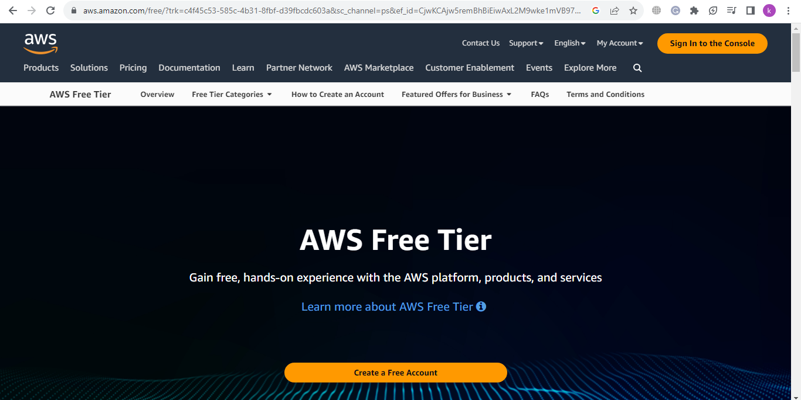

4. Go to **Sign in to the console** option. If does not have an account, then go to **Create a Free Account** option:

5. When logged in the **Console Home** page will appear:

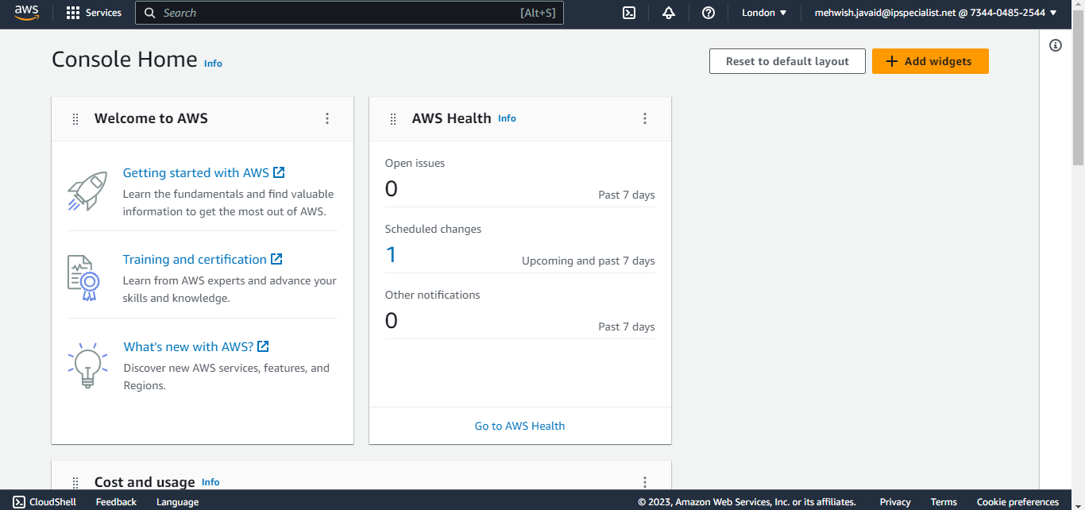

6. Search **EC2** on the search bar, then click on the **EC2** option:

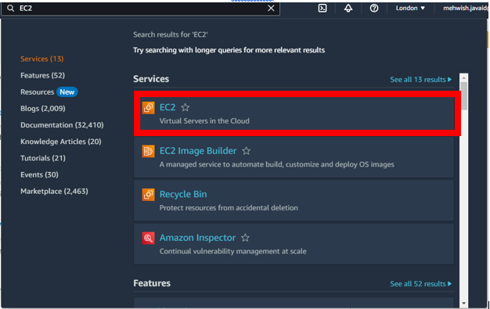

7. Click on **instances** under **instances** heading:

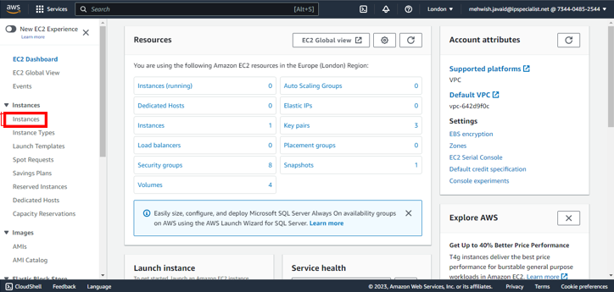

8. Now, you can see the instances that are already made:

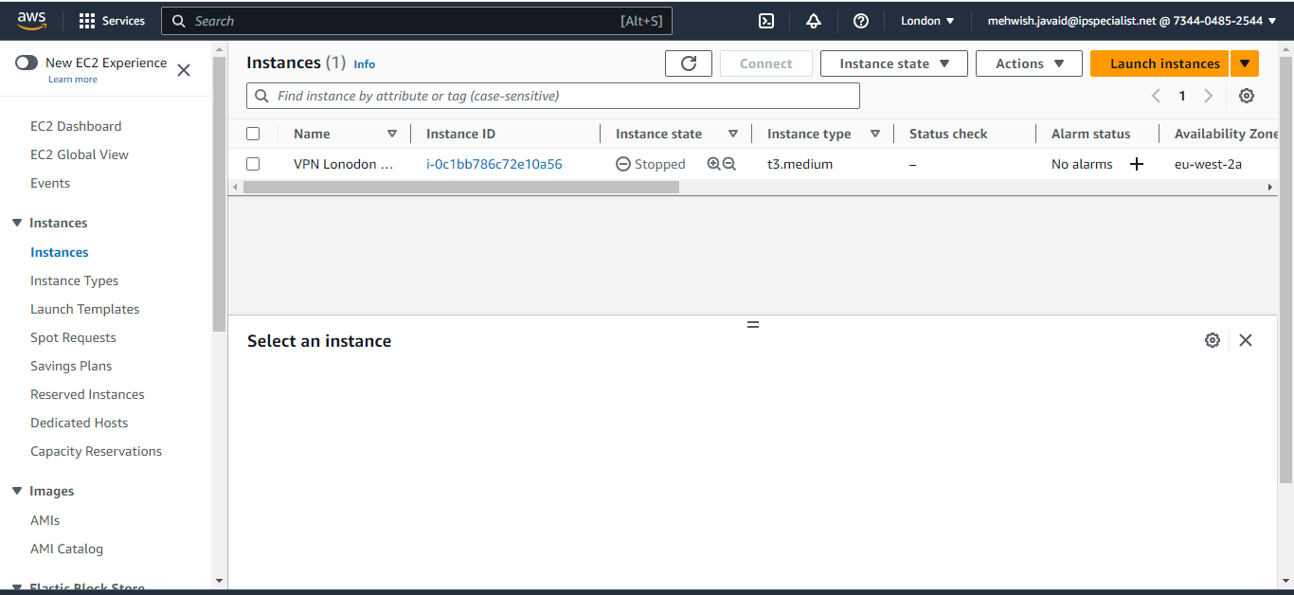

9. Then click on **launch instance**:

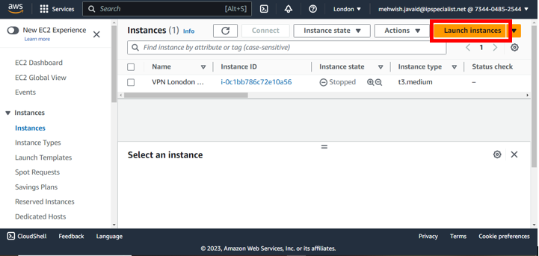

10. Give your instance a name. E.g. LinuxMachine:

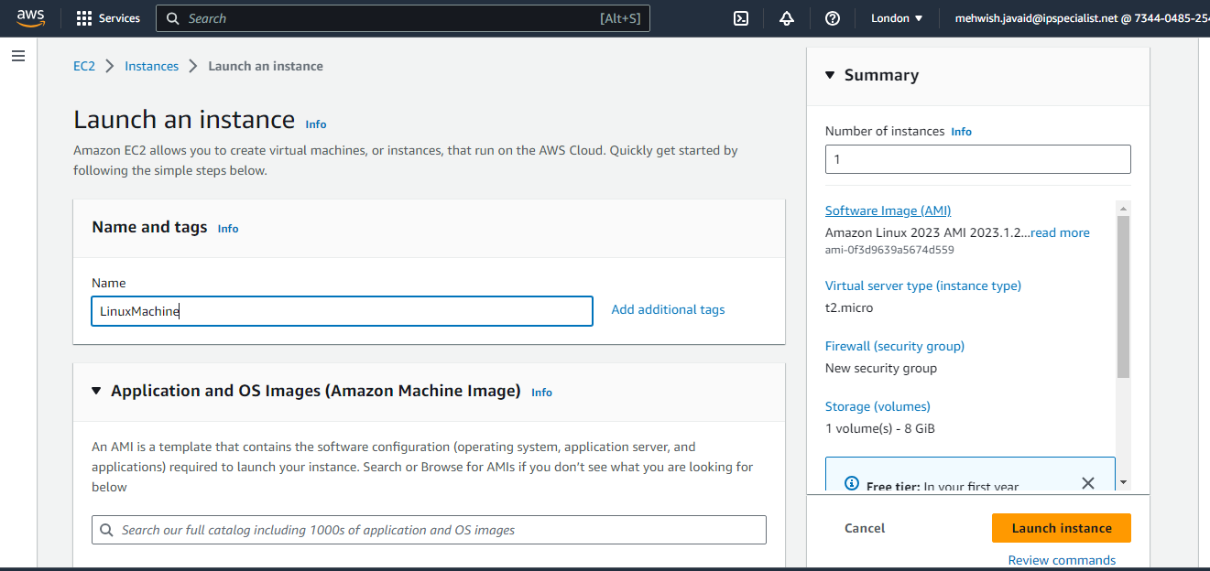

11. Scroll down and select the Amazon Linux AMI:

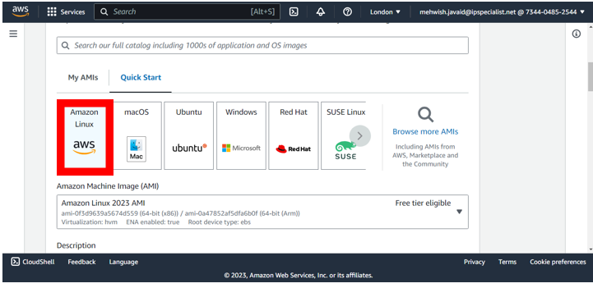

12. Click on **create new key pair** under Key Pair:

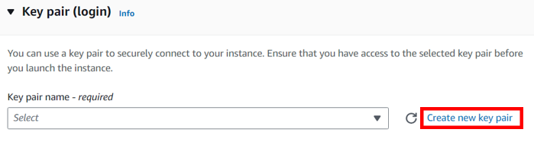

13. Enter the **key pair name** and then select .**pem:**

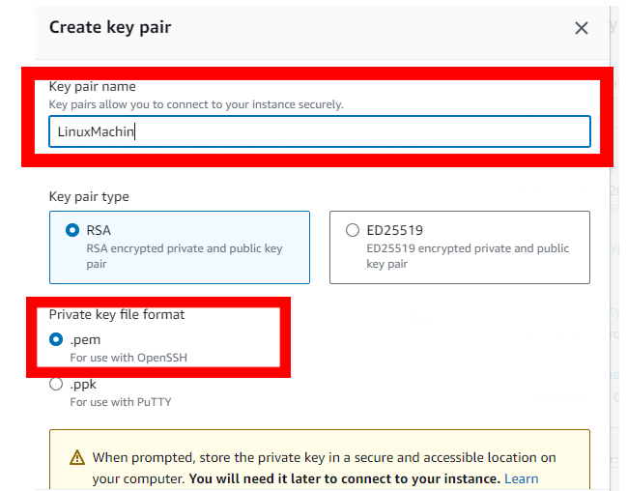

14. Click on **Create key pair:**

**Note:** Save the key pair anywhere on your computer.

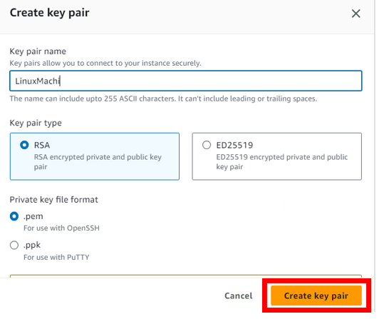

15. Click on **Add new volume** under **Configure storage:**

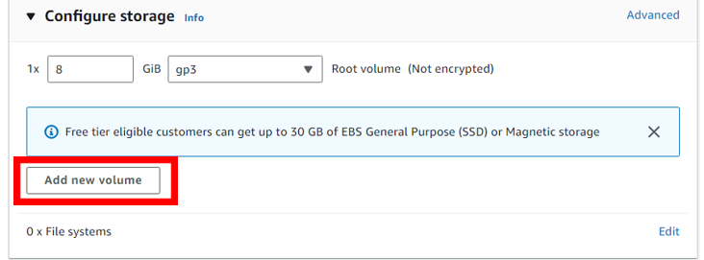16. Increase the size to 12 GiB:

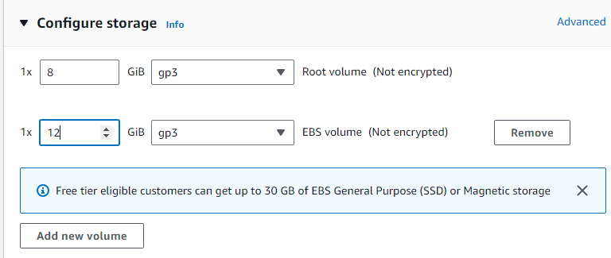

17. Click on **Launch instance:**

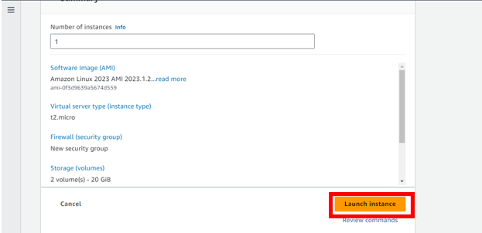

18. Now, the instance is successfully created:

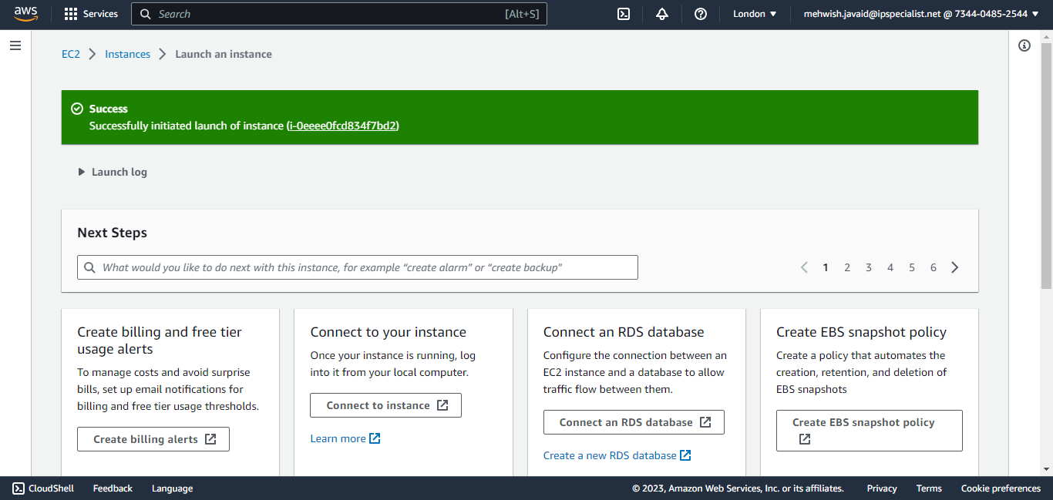

19. Scroll down and click on **View all instances**:

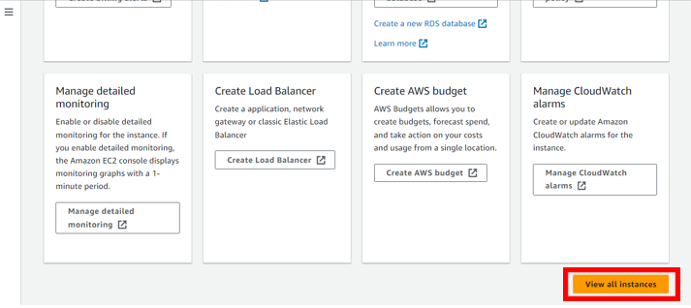

20. Now, the machine is in a running state:

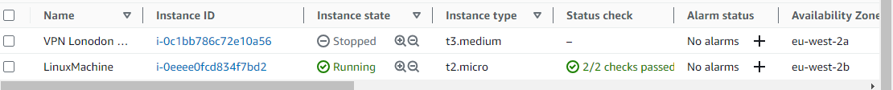

21. To connect the instance, select the instance and click on connect:

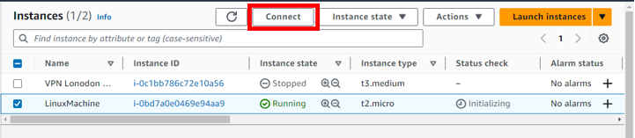

22. To connect, you must have Putty and Puttygen. To download Putty, use the following link:

<https://www.putty.org/>

For Puttygen, use the following link:

<https://www.puttygen.com/>

Open Puttygen:

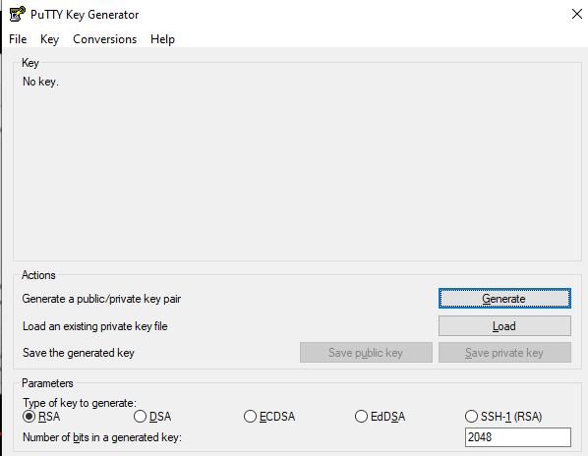

23. Choose **RSA:**

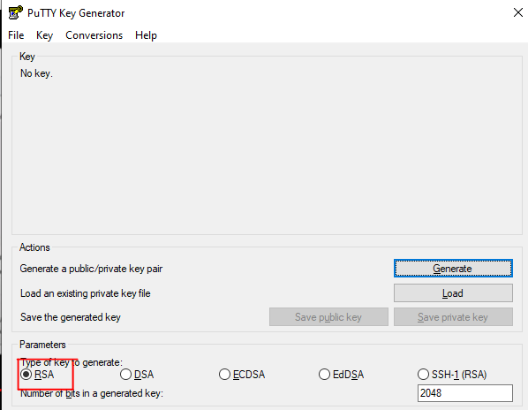

24. Click on **Load**:

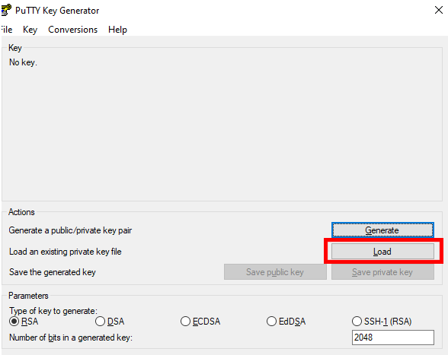

25. Go to the folder where you saved the key pair.

26. Change format to All Files:

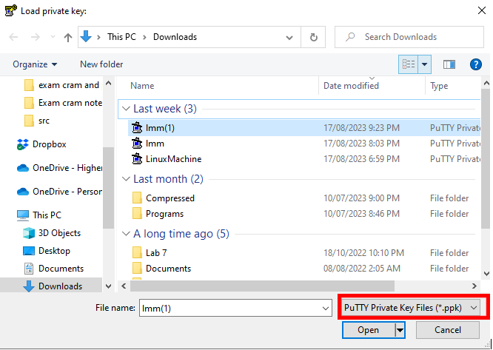

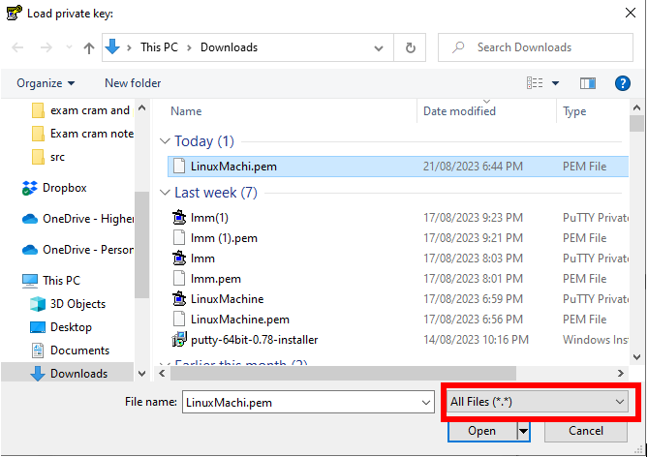

27. Select the **.pem** file and click **Open:**

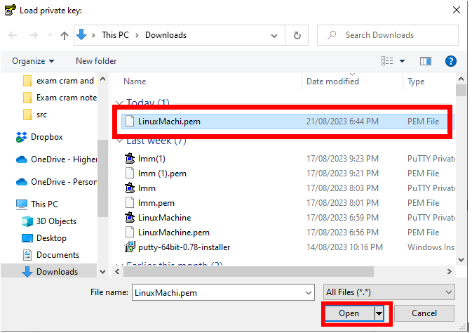

28. Click on **Save Private Key:**

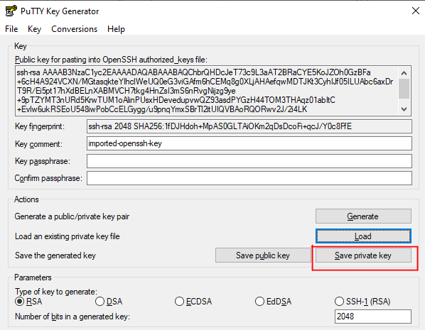

29. Give the same name that you used to create the key, then click **Save:**

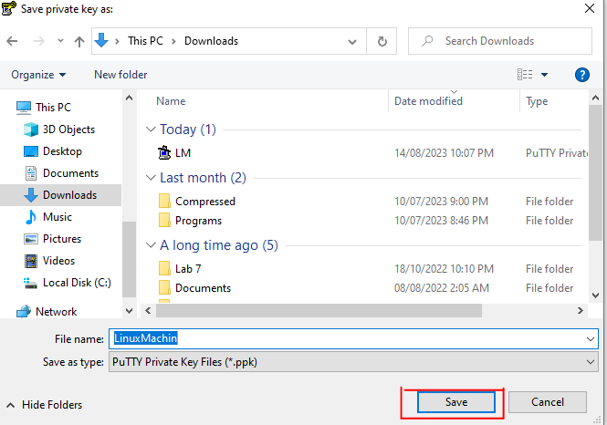

30. Now, open **Putty:**

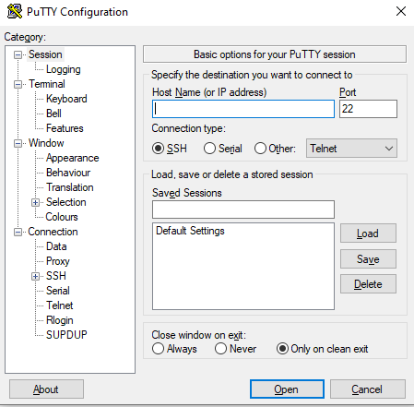

31. Choose **Session** under **Category:**

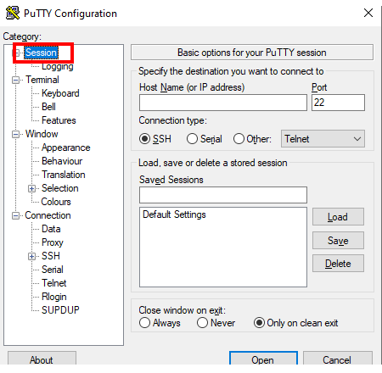

32. Copy the **Public DNS** along with the user name of your EC2 instance in SSH client:

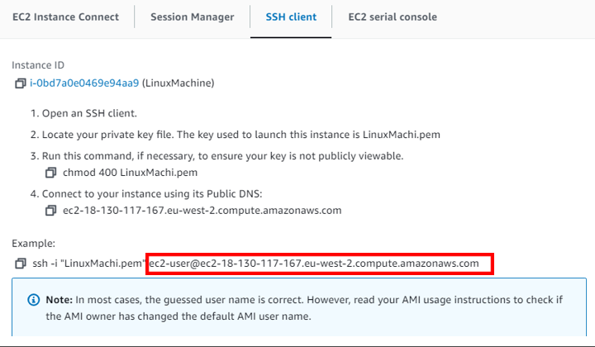

33. Paste the Public DNS and username on the Host name (or IP address) in Putty:

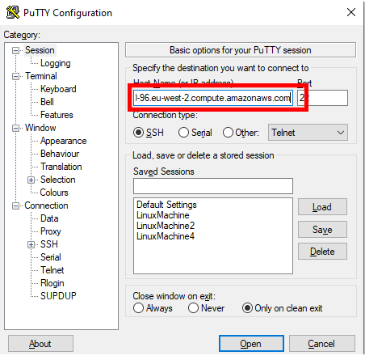

34. Give any name to the session and then save it:

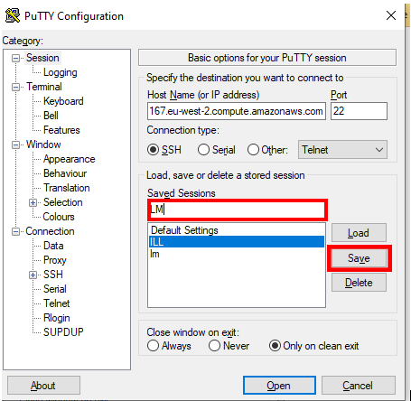

35. Select SSH under Connection:

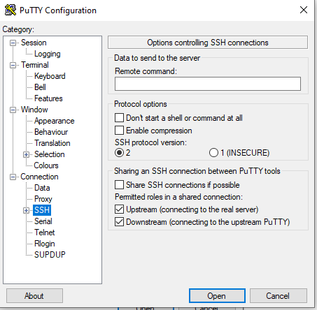

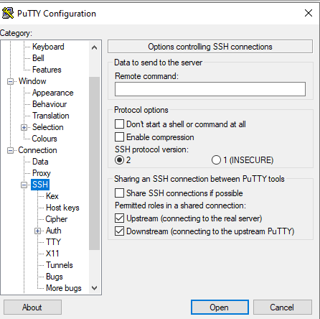

36. Now, go to **Auth** then, go to **Credentials** under **Auth:**

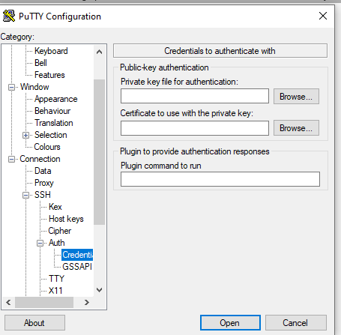

37. Click on Browse for **Private key:**

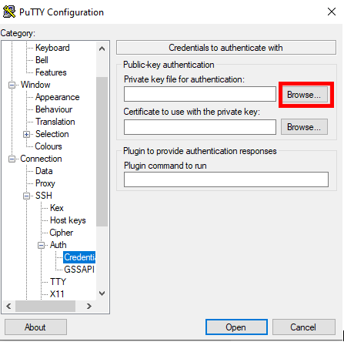

38. Select your private key and click **open:**

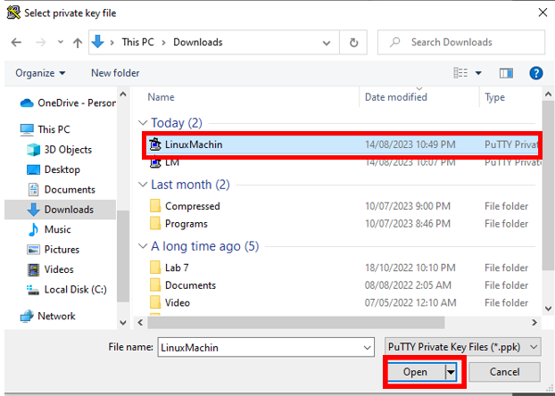

39. Now, go back to **Session:**

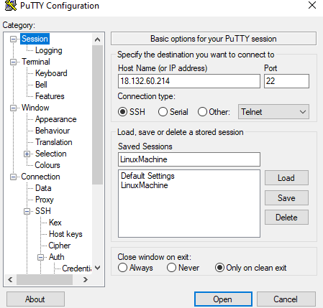

40. Select LinuxMachine and click on **Save:**



41. Go to **Connection:**

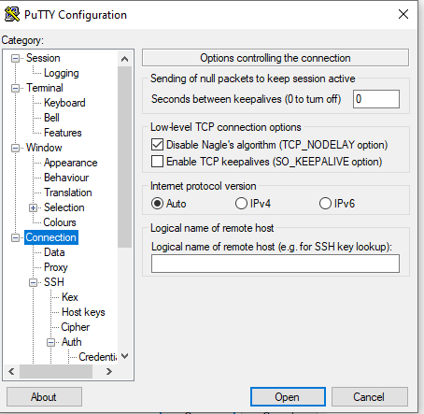

42. Change Seconds between keepalives to 100:

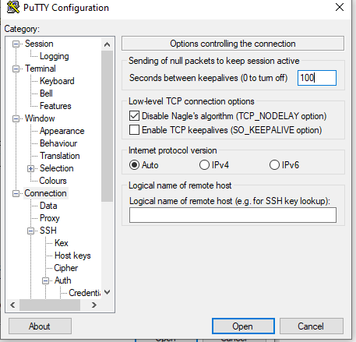

43. Now, go back to Session:



44. Select LinuxMachine and click on **Save:**



45. Select LinuxMachine and click on **Load:**

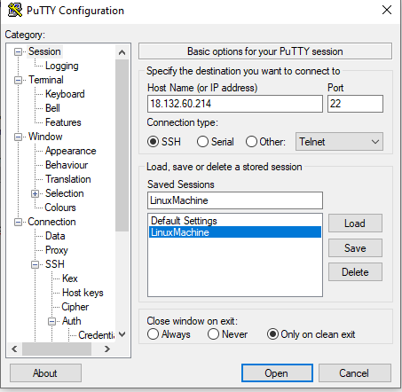

46. Then click on **Open:**



47. Now, you are connected to you Linux system:

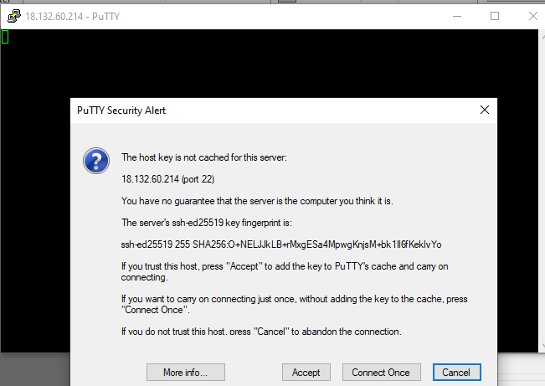

48. Click on **Accept** on **Putty Security Alert.**

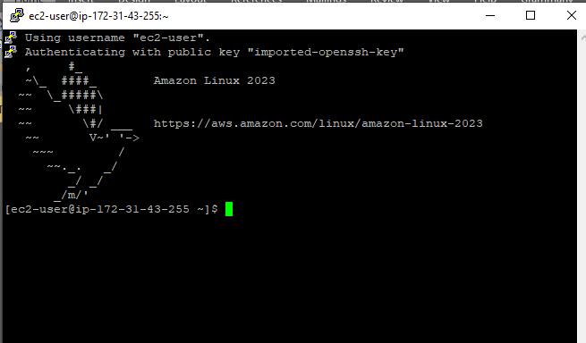

## Lab 3-10: Launching an EC2 Instance in a Custom Virtual Private Cloud (VPC)

### Service Introduction

Launching EC2 instances within a custom VPC gives you greater control, security, and flexibility over your network infrastructure, aligning it precisely with your organization's requirements and enhancing overall system performance and security.

### Problem

Let's consider you are a web developer in an organization. You develop a website and deploy it on a cloud server. Now, the cloud server has access to the public internet, and you also create another cloud server database and connect it to a website. So, the website and database communicate with each other. However, you do not want the traffic that comes to your website via the public internet not to affect your database. So it would help if you created a cloud server where no traffic comes to your database but instead comes to your website via the public internet.

### Solution

The solution you create is a Custom Virtual Private Cloud (VPC). Add two subnets across multiple availability zones, routes, and an internet gateway. Then, launch two EC2 instances using the proper security and test access. These services are the foundation of the networking architecture inside AWS. You built a secure and scalable architecture to host your website.



**Follow the given steps to launch an EC2 instance in a custom VPC.**

1. Log in to your AWS Console.
2. Click on ‘Services’.
3. Select VPC from ‘Networking & Content Delivery’.

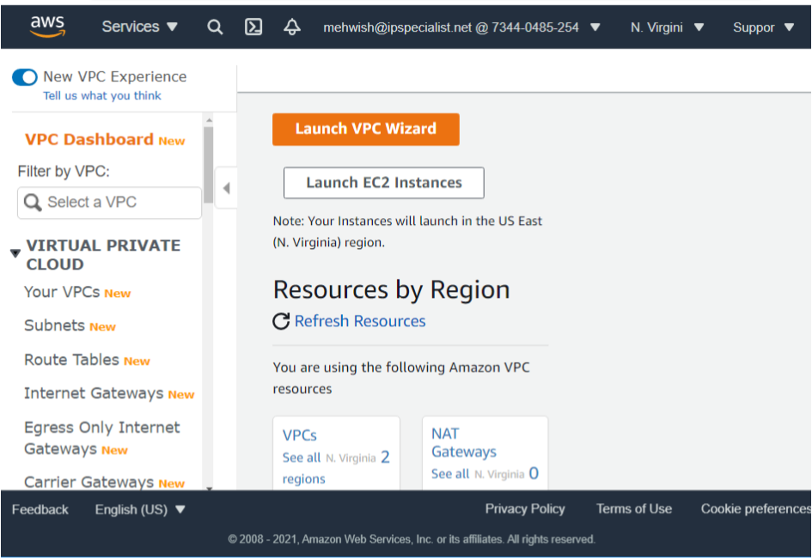

1. It brings us to the initial VPC dashboard. In this, we will create a custom VPC.

**Note:** VPC allows you to create a private network that isolates from other private networks in AWS to secure your resources. Create a VPC from scratch. Do not use the ‘Launch VPC Wizard’.

1. To create a VPC, navigate to the left-hand side and click on ‘Your VPCs’.

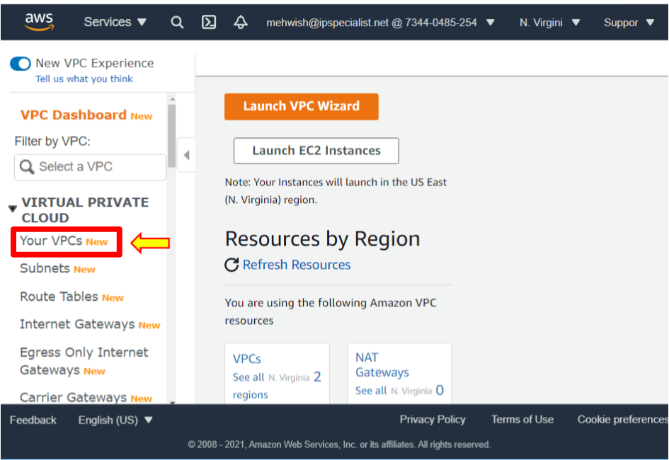

1. Now, you see the dashboard. In the upper right-hand corner, click ‘Create VPC’.

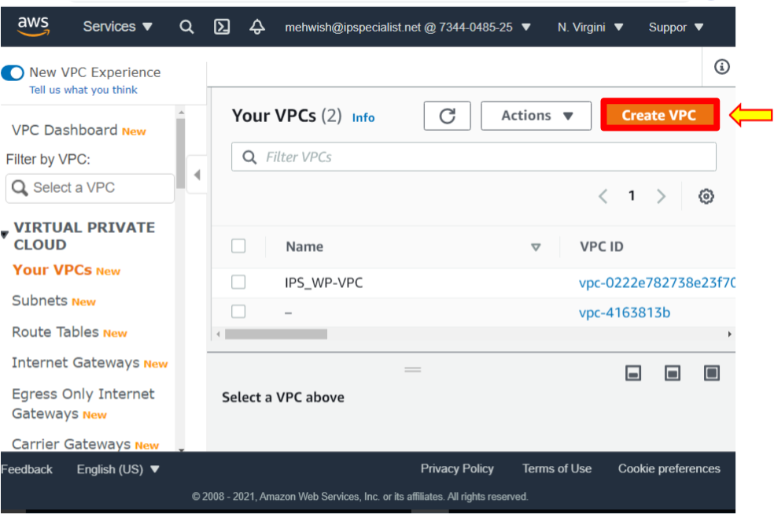

1. Now, give VPC a name; let’s call it ‘IPS-HolVPC’.
2. Enter the CIDR block, which is the IP address range for this VPC. Type ’10.0.0.0/16’.
3. You should not use IPv6 CIDR blocks and make sure no IPv6 CIDR Block is selected.
4. Leave ‘Tenancy’ as it is the default. It means you are using shared hardware.
5. The other option is dedicated. It means you have dedicated hardware but leave it default.

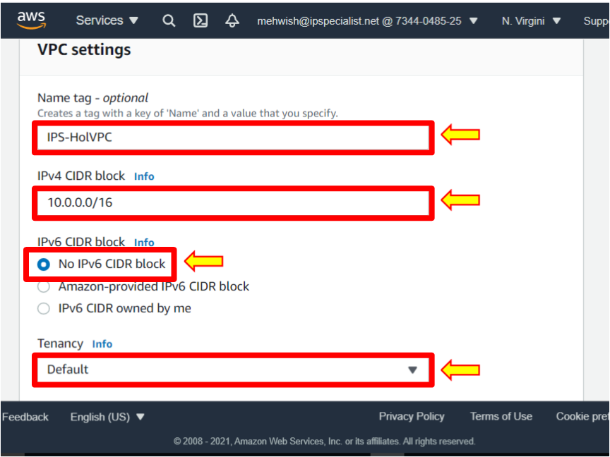

1. Leave the default tag. This is the name of VPC. You can add additional tags like the department this VPC is associated with, marketing department, IT department, etc., but leave the name for now.
2. Click ‘Create VPC’, and your VPC is now up and running.

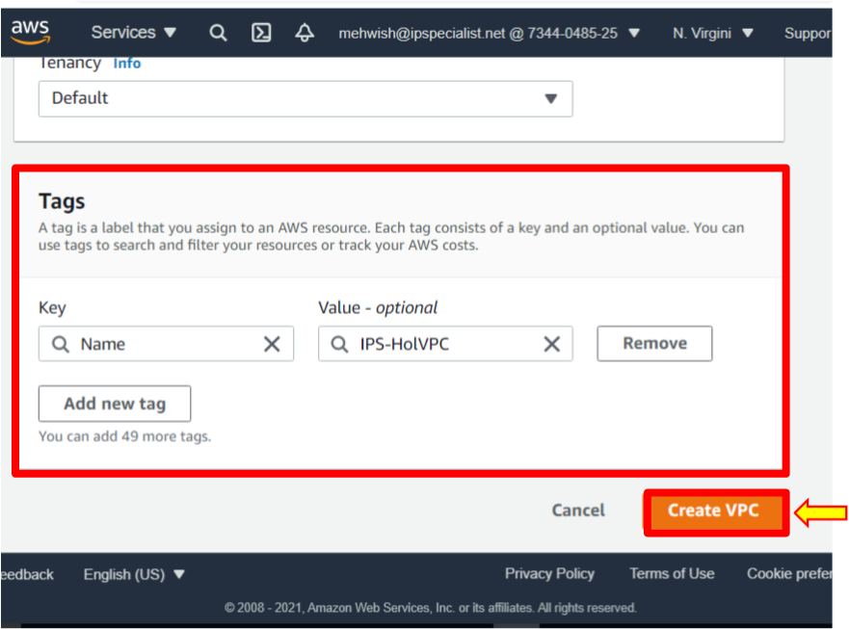

1. Now, create the public and private subnets.
2. VPCs contains subnets or isolated local network that use a subnet of the CIDR block range to find the overall VPC. Launch your resources and services directly in a subnet, so services like EC2 instances are not typically launched directly in a VPC; they are launched in a subnet.
3. On the left-hand side, click ‘Subnets’ to create a subnet.

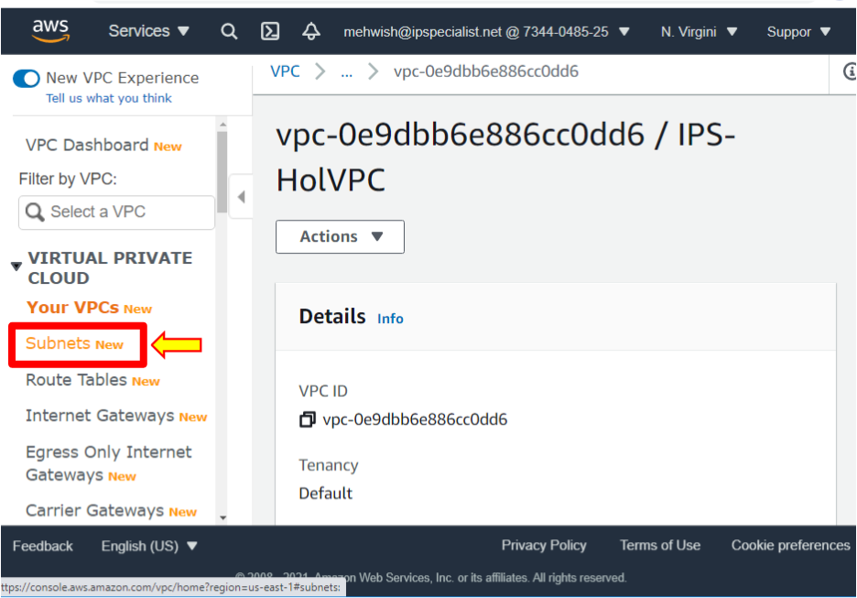

1. Click ‘Create Subnet’.

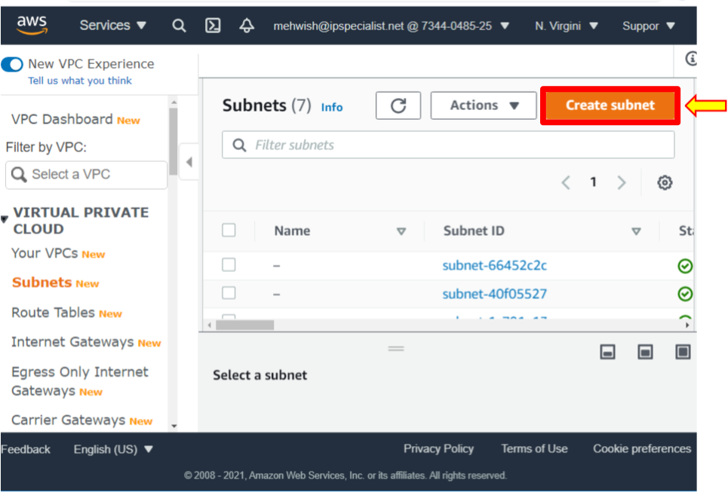

1. Select the VPC we created, ‘IPS-HoLVPC’.

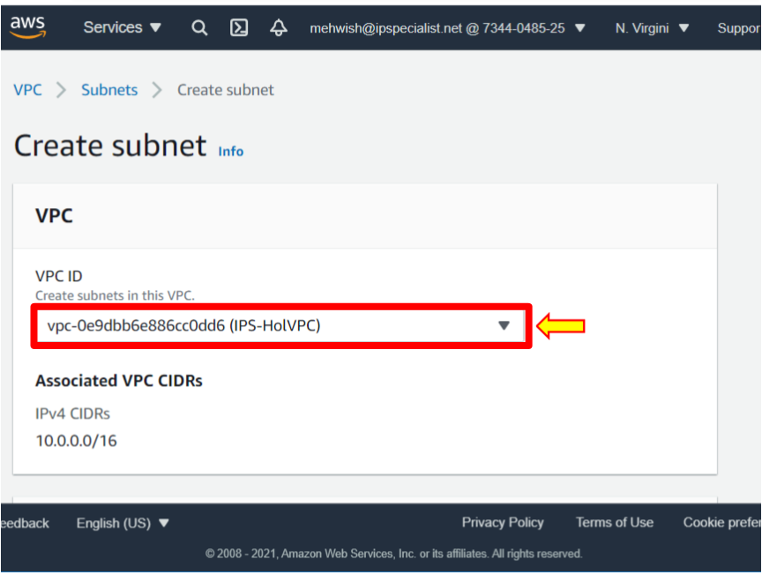

1. Give the subnet the name ‘IPS-snpublic-a’. So this is a public subnet.
2. When creating a subnet, you must select the availability zone. Each subnet must reside entirely within one availability zone and cannot span zones.
3. Put this subnet in ‘us-east-1a’.
4. VPC CIDR shows the CIDR block range for the VPC. When you create a subnet, you specify the CIDR block for that subnet; in this case, type ’10.0.1.0/24’.

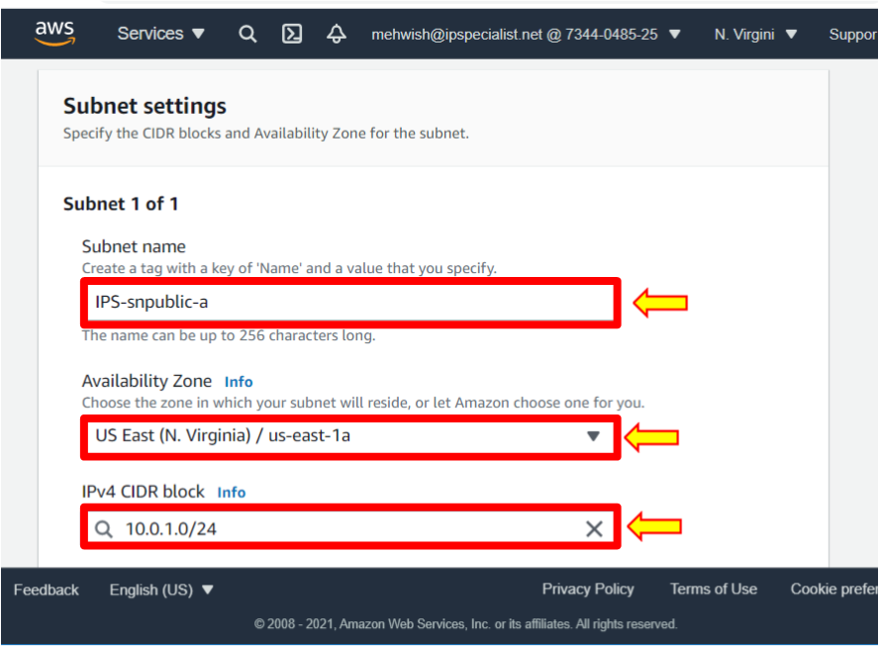

1. Click ‘Create Subnet’.

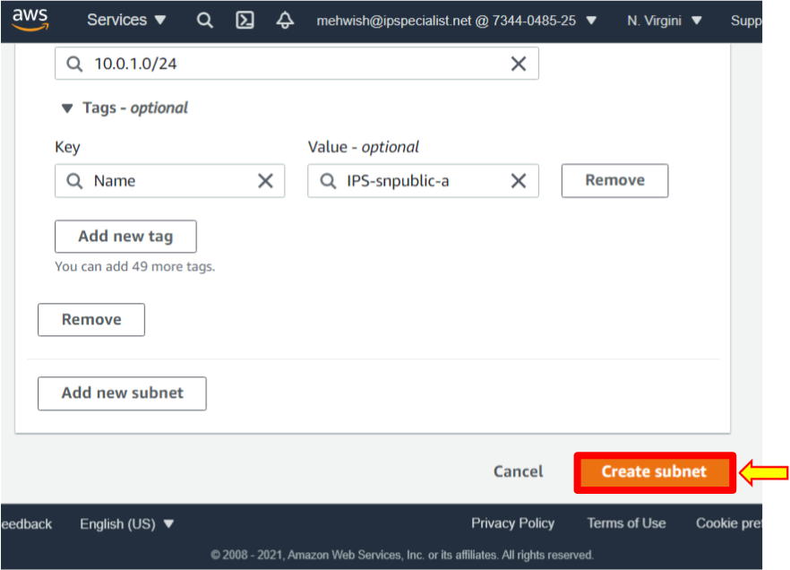

1. After that, you will see that the state of the subnet is available.
2. Although we named this subnet a public subnet, it is not public just yet; there are additional configurations to make it publicly available over the internet.

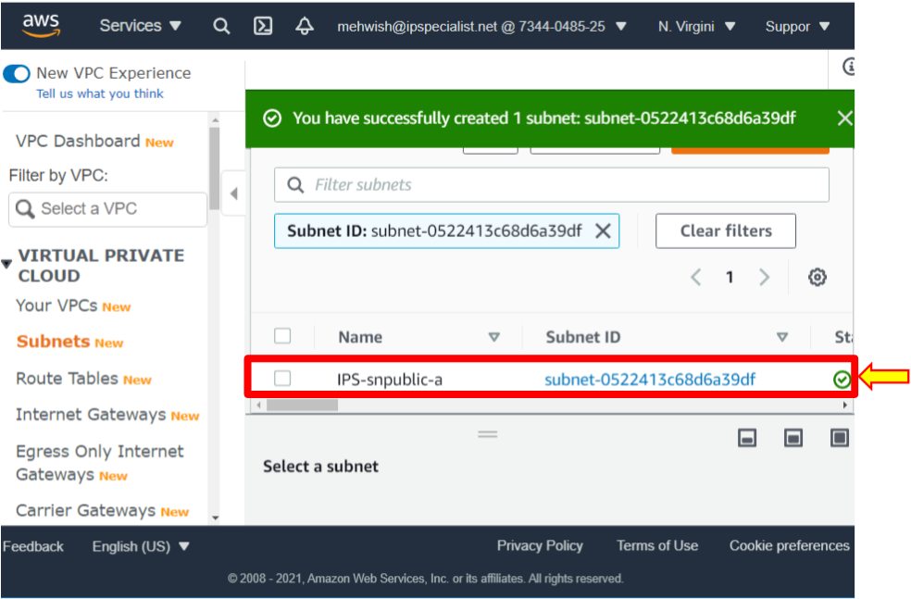

1. Next, create a private subnet that follows the same path.
2. Click ‘Create Subnet’.
3. Select the VPC that was created.
4. Give the subnet the name ‘IPS-snprivate-b’.
5. This time for the availability zone, select ‘us-east-1b’.
6. For the CIDR block range, type ’10.0.2.0/24’.

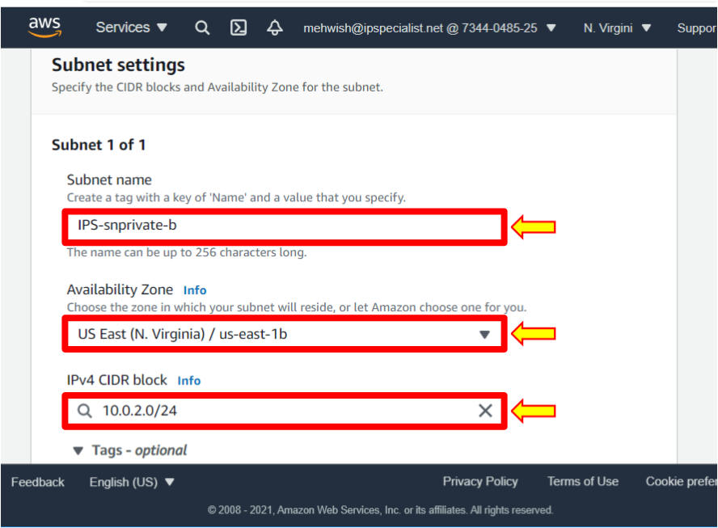

1. Click ‘Create Subnet’.
2. Created two subnets in VPC, one public subnet and one private subnet.

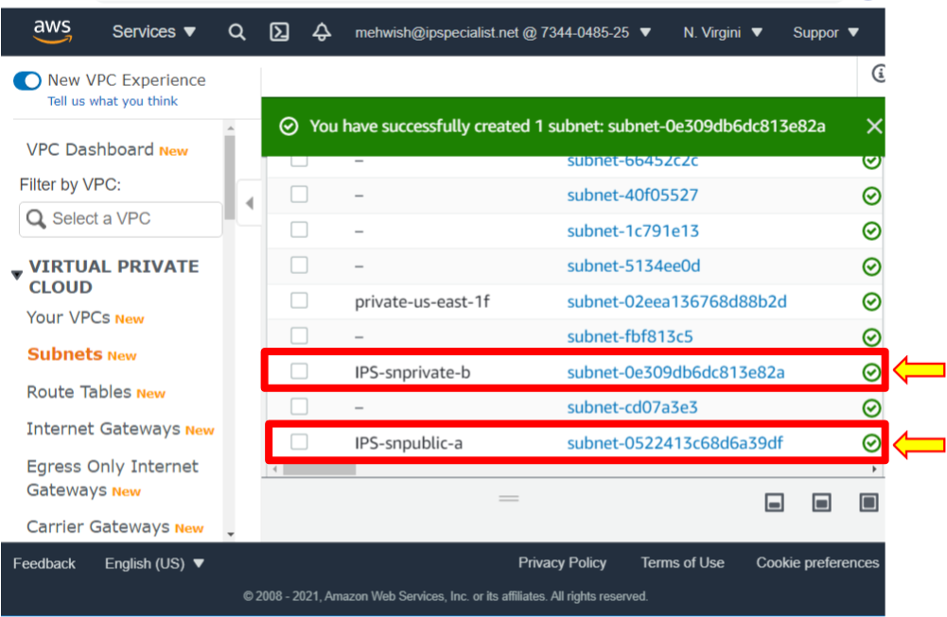

1. Now, we will look at the routing inside VPC, which defines traffic within subnets and from the internet. There is one route table per VPC.
2. Click on ‘Routes Tables’.

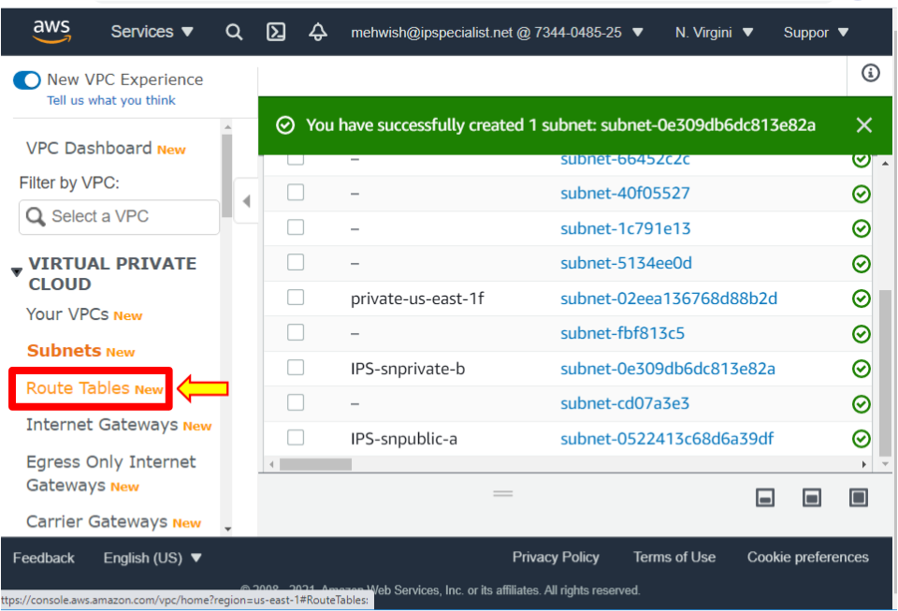

1. To see the “Route tables”, scroll down and click on ‘Routes’.

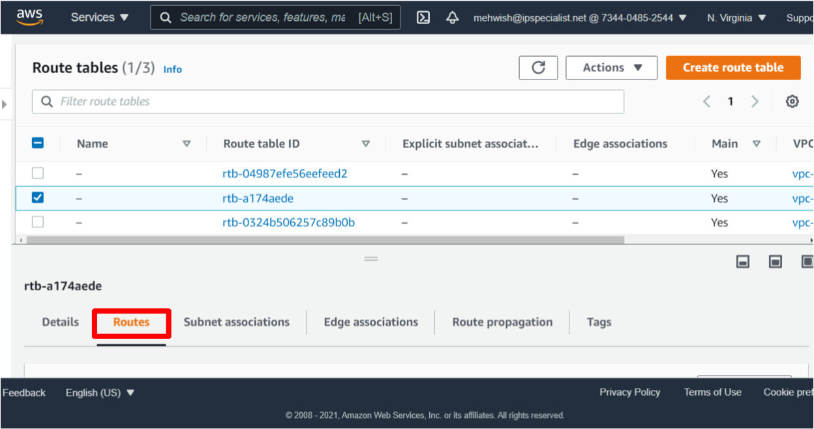

**Note:** This route allows traffic to pass to other nodes within the network but does not allow traffic outside the network, such as to the public internet. All VPCs you create by default get associated with the main route table.

1. To make a public subnet public, select ‘Subnets’.
2. Select the ‘Public Subnet’.
3. Click on ‘Actions’ and Click ‘Modify Auto-Assign IP Settings’.

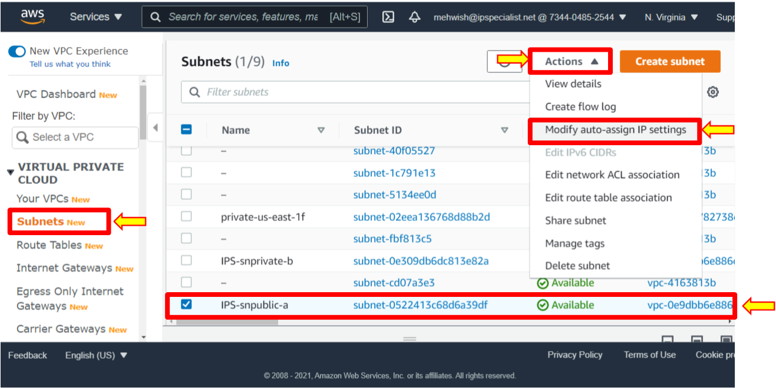

1. Click enable ‘Auto-Assigned Public IPv4 Addresses’.
2. Since the launched instances in this subnet set the automatic request a public IPv4 address for instances.
3. Click ‘Save’ and configure the internet gateway.

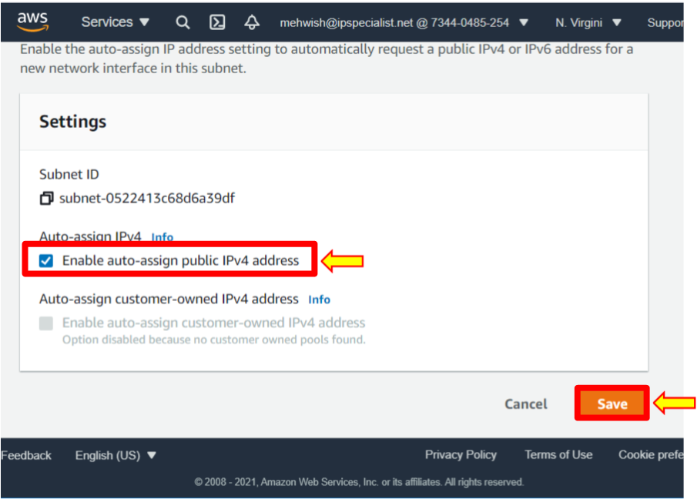

1. Click ‘Internet Gateways’, then click ‘Create internet gateway’.

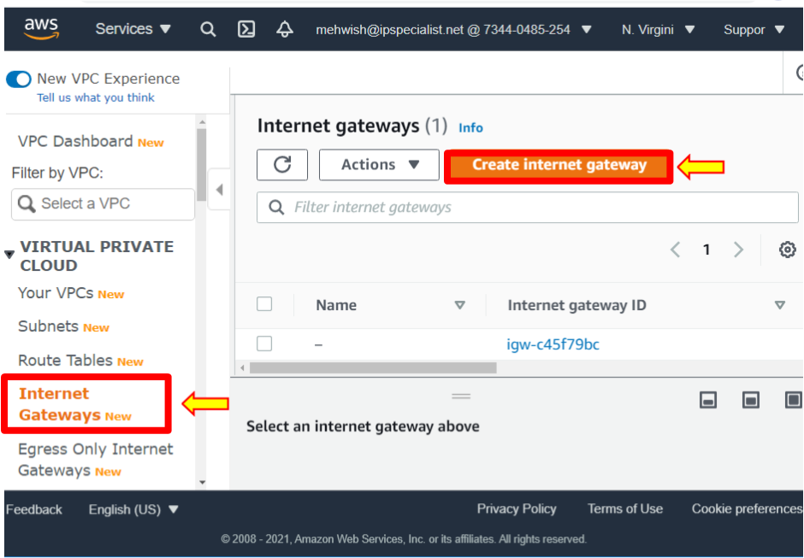

1. The internet gateway is a virtual router that allows the VPC to connect to the internet. Give a name to the internet gateway ‘IPS-holVPCIGW’. Leave the name as the default tag.
2. You can add additional description tags to help you track and monitor this internet gateway, but for now, leave your name and click ‘Create internet gateway’.

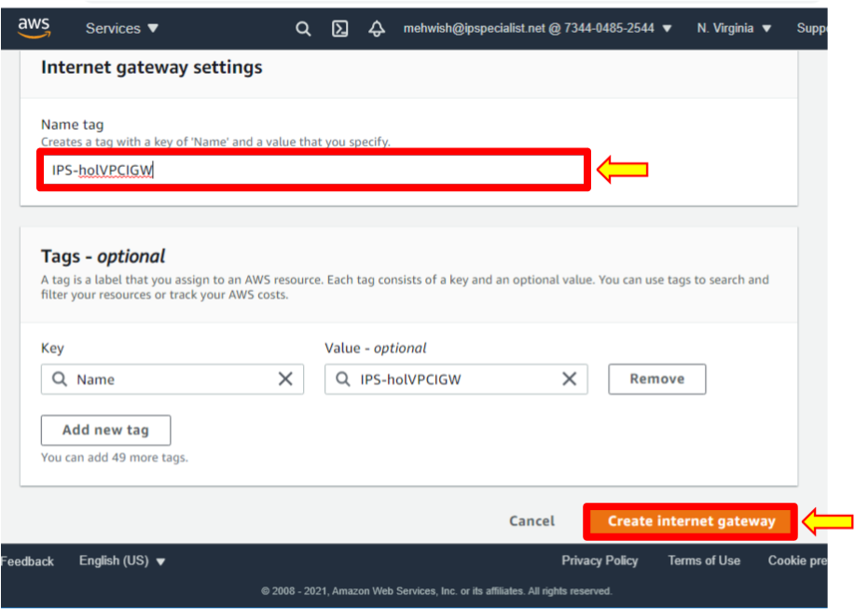

1. Notice that the created internet gateway is in the state of ‘detached’ and requires something for connection.
2. In this case, attach the internet gateway to VPC. You can do that by clicking on ‘Actions’ in the upper right-hand corner and then clicking ‘Attach to VPC’. Select the VPC which created ‘IPS-HoLVPC’.

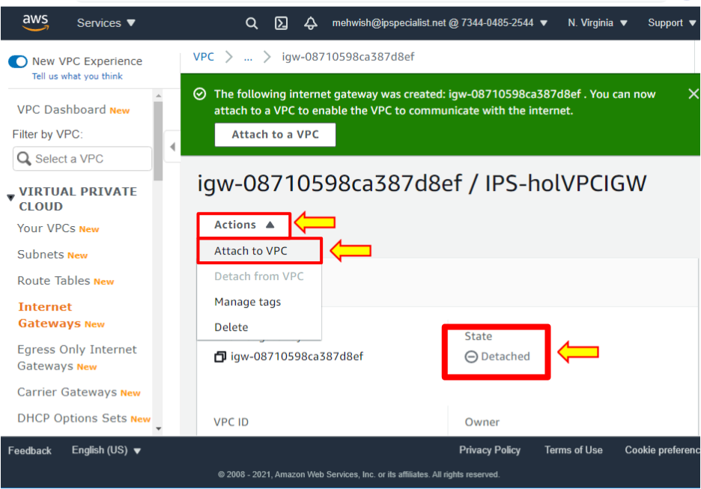

1. Click ‘Attach internet gateway’.

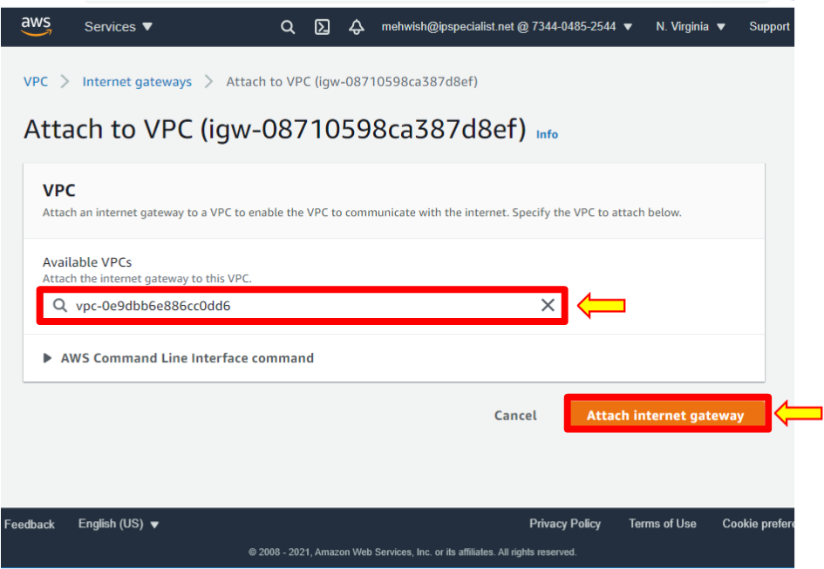

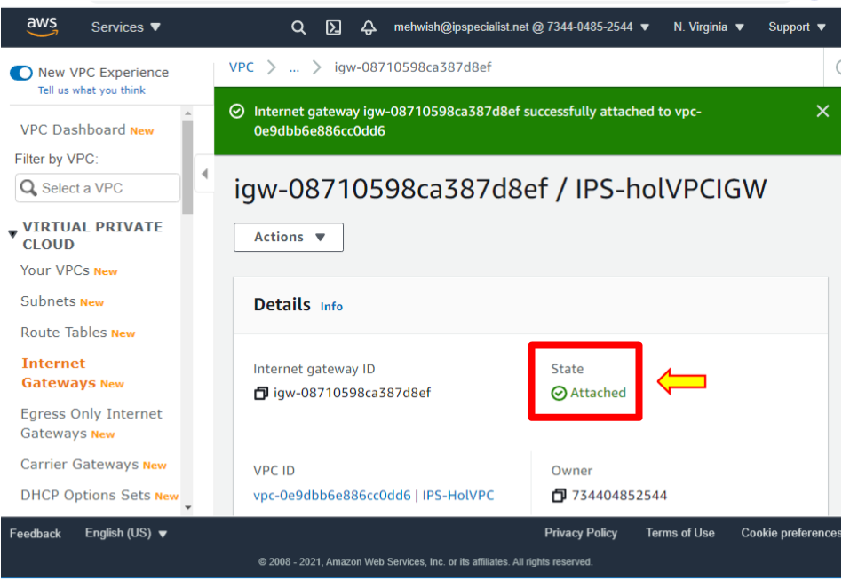

1. To set up the internet gateway, you need to configure routing.
2. Now, go back to the route tables. Leave this default route table as is.
3. In all VPCs, you create, by default, ‘get associated with the main route table’.
4. Create a route table for public internet traffic by clicking on ‘Create Route table’.

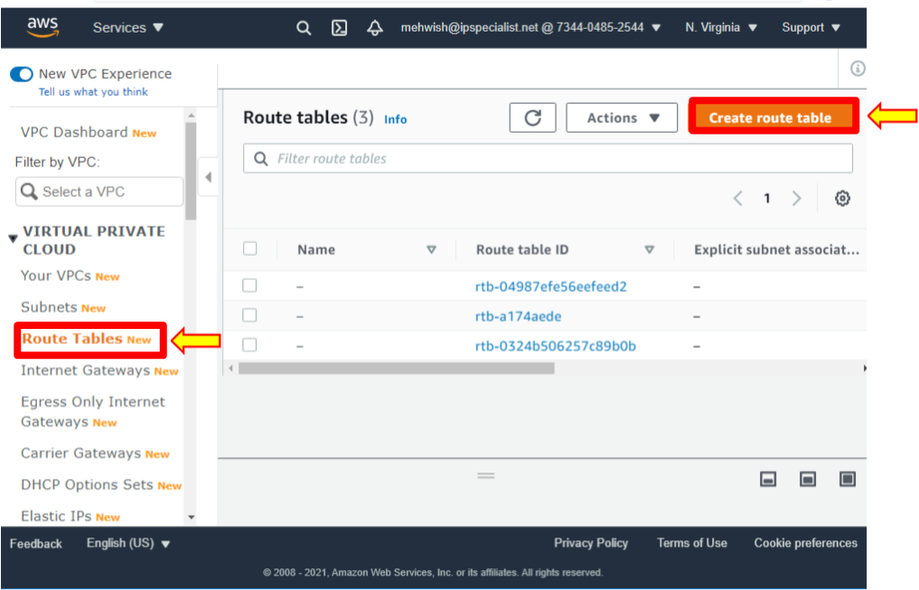

1. Name this ‘IPS-publicRT’ for the route table and select the created VPC. Please do not add a tag; leave it as default. Click on ‘Create’.

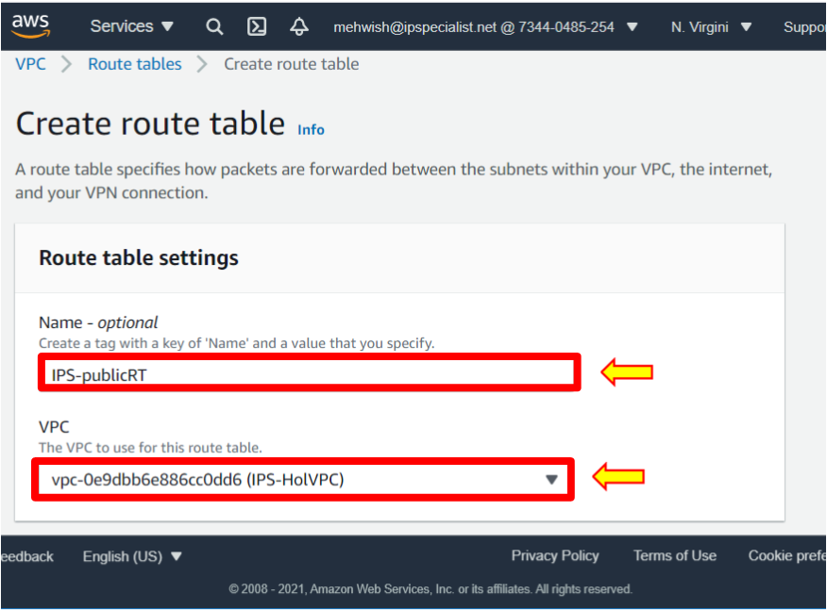

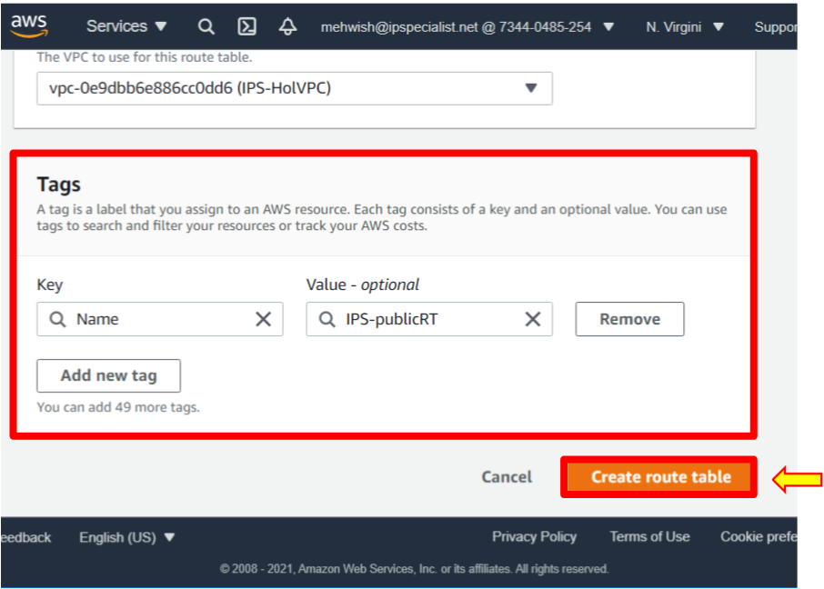

1. Then, select the newly created route table.
2. Click the ‘Routes’ tab. The local route allows traffic to pass to other nodes within the network but does not allow traffic to go outside the network, such as to the public internet. So fix that.
3. Click on ‘Edit Routes’.

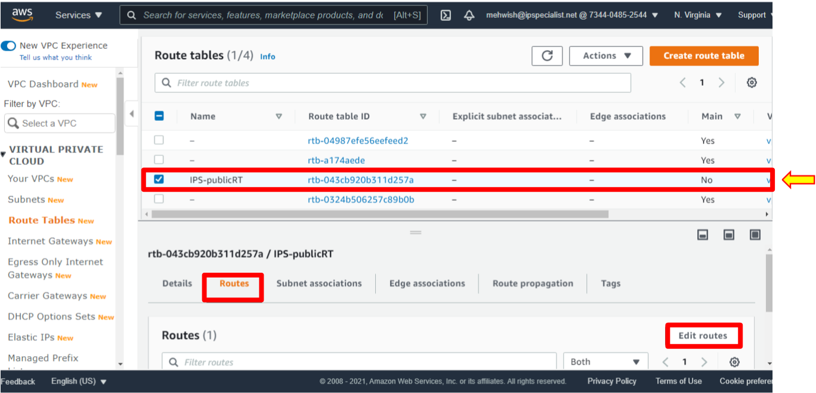

1. Click ‘Add route’, set destination zero ‘0.0.0.0/0’, and type it default value. It essentially represents the public internet.
2. Select targets as ‘Internet Gateway’.
3. Select the internet gateway that was created.
4. Click ‘Save Changes’.

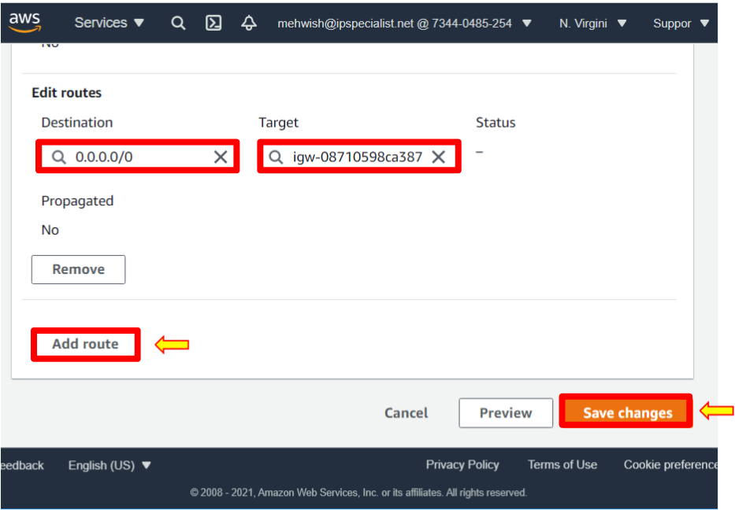

1. The public route table is now created.
2. The traffic is allowed to the public internet.
3. Now, associate this route table with the public subnet. To do this, make sure the public route table is selected.
4. Click on the subnet associations tab.
5. Click ‘Edit’ subnet associations.

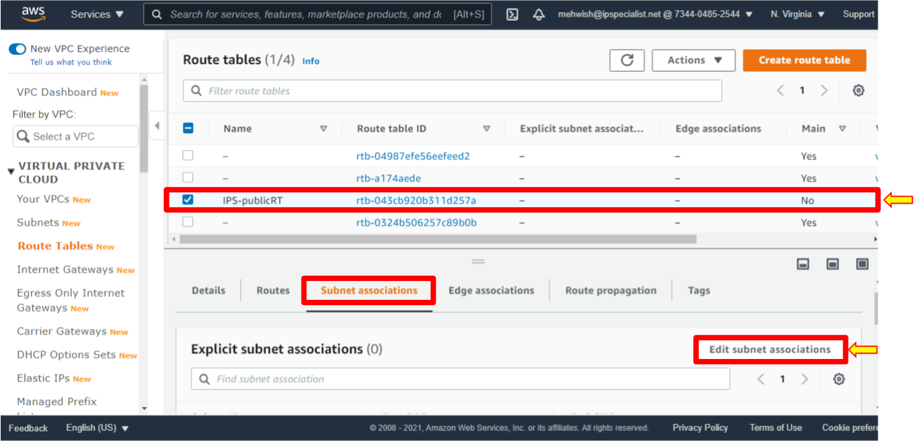

1. In this case, select the public subnet ‘IPS-sn-public-a’ and notice it is now associated with the main or default route table.
2. Change the subnet association, select it, and click ‘Save associations’.

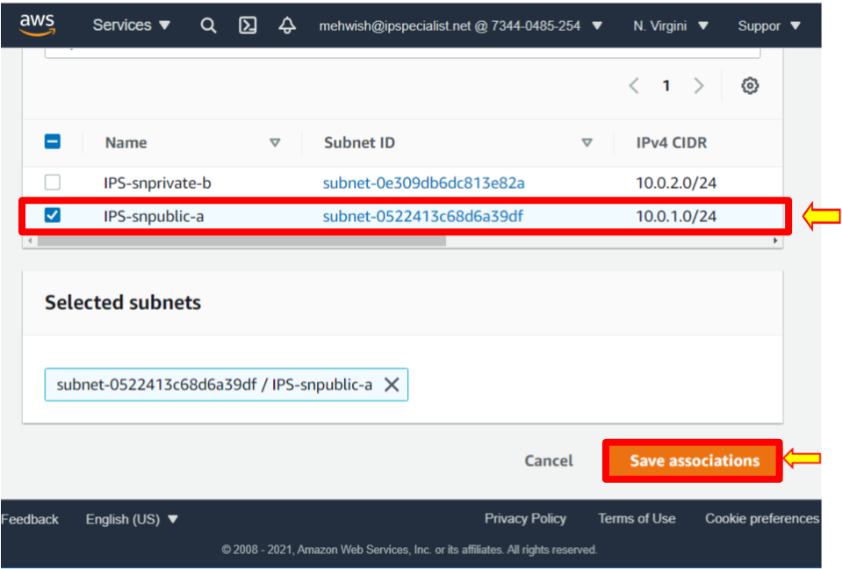

1. The public subnet allows traffic to access the public internet. Click on ‘Subnets’
2. Select public subnet.
3. Click on the Route table and see that it is associated with the public route table.

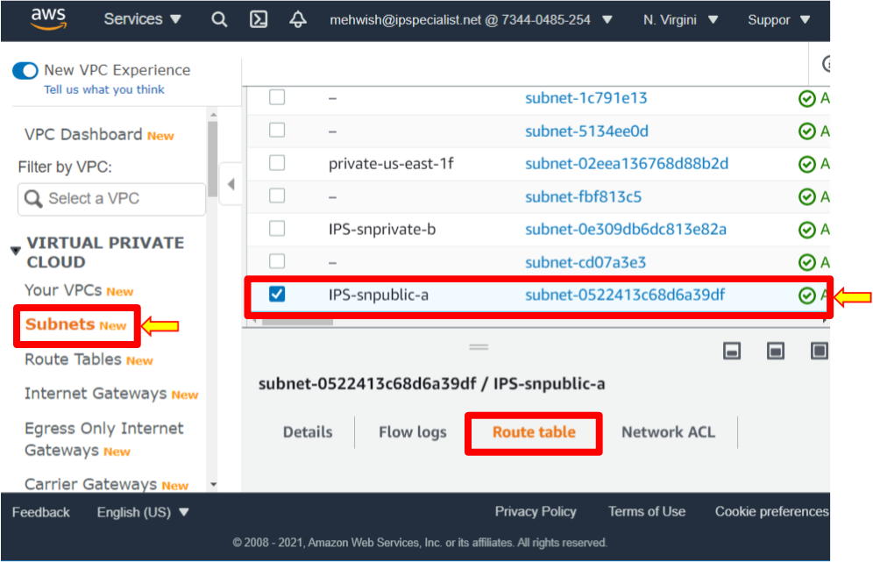

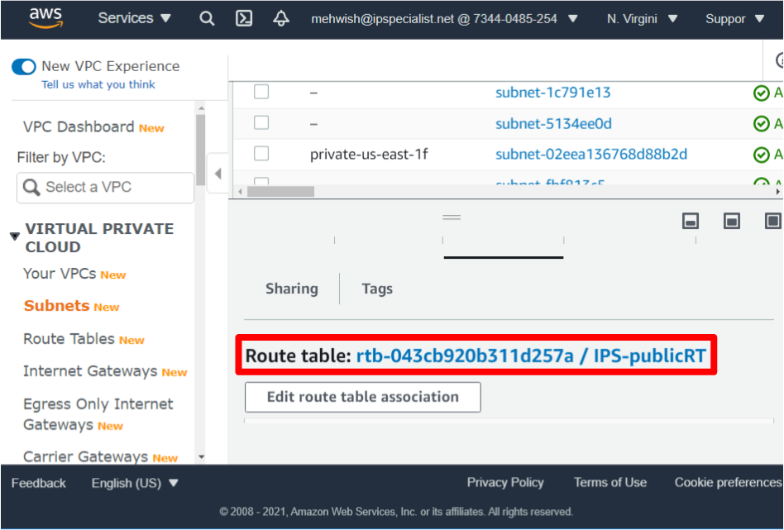

1. Click on a private subnet.
2. Notice the route table is the default route table.

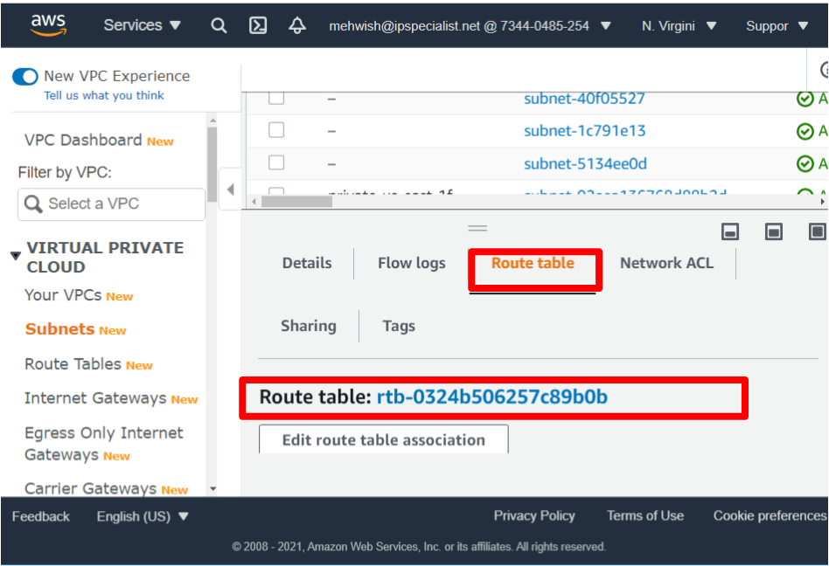

1. Notice that you do not change the configuration for this private subnet because if a subnet does not have any route to the internet gateway, then the subnet is known as a private subnet. Therefore, the instance in this private subnet cannot reach the internet but can reach other instances in the VPC.
2. Now, launch EC2 instances.
3. Click on ‘Services’, then select EC2 from Compute. It brings the EC2 dashboard to launch the instance.
4. Select instances from the left-hand side, and in the upper right, click launch instances.

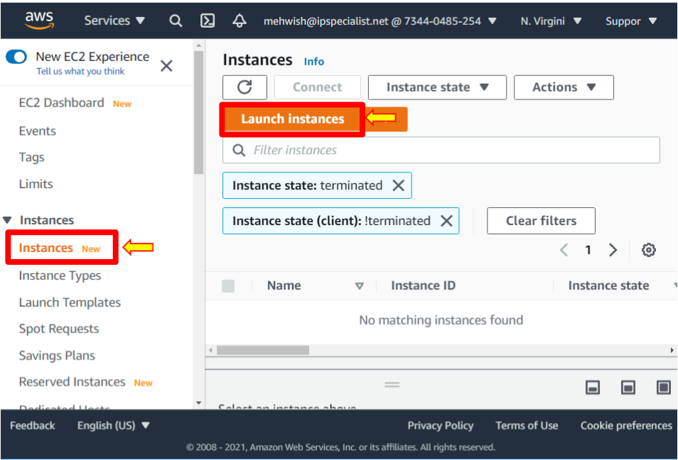

1. In this instance, choose the ‘Amazon Linux 2 AMI 64-bit’. Click ‘Select’.

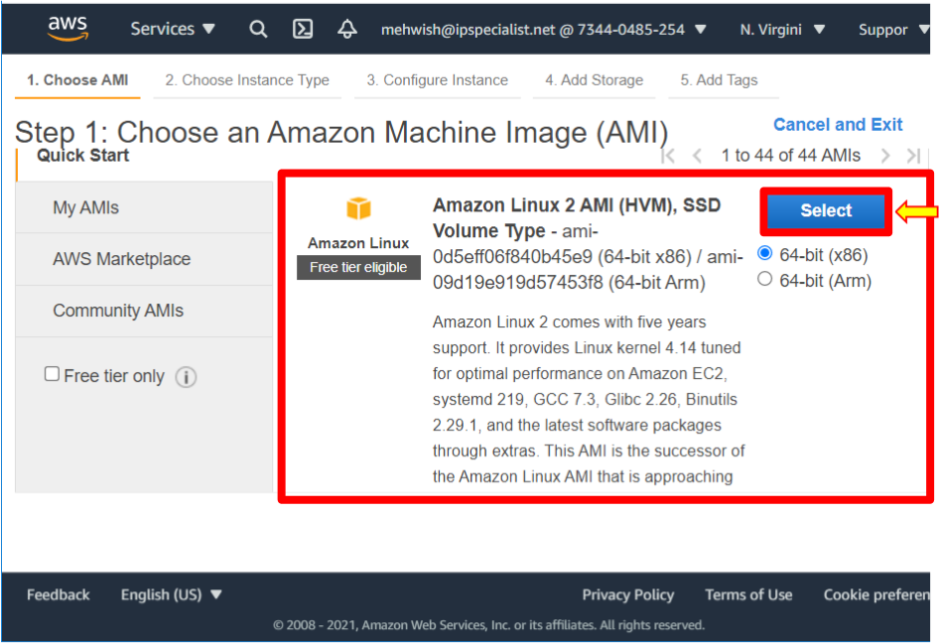

1. In this case, leave the free tier eligible T2 micro selected and click ‘Next: Configure Instance Details’.

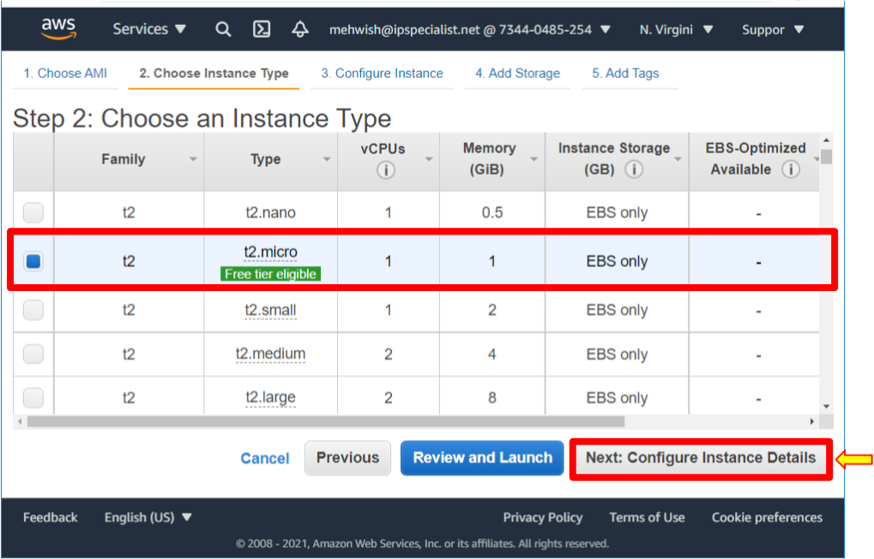

1. Leave all the defaults number of instances, as we will not request spot instances.
2. For network use, the VPC created ‘IPS-HoLVPC’.
3. Now, for the subnet, The first step is to create an EC2 launch in the public subnet. Select the drop-down and make sure you have selected ‘IPS-sn-public-a’.
4. For Auto-assigned public IP, remember to enable it for the subnet. Make sure to use the subnets setting.
5. Scroll down, keep the rest as defaults, and select ‘Next: Add Storage’.

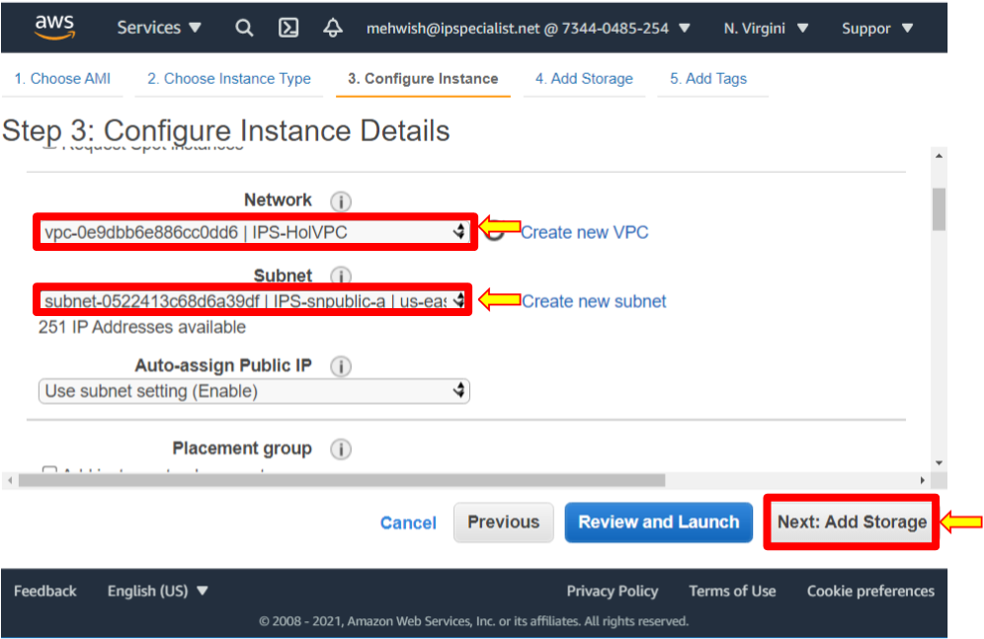

1. It shows the storage that the instance will be launched with.

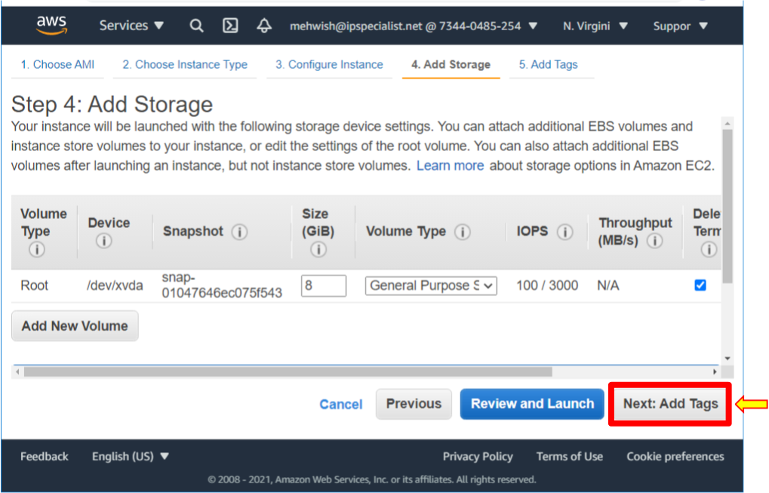

1. Here, you can add a tag like a department name or other useful information that will help you monitor this resource. But for now, we will skip tags.

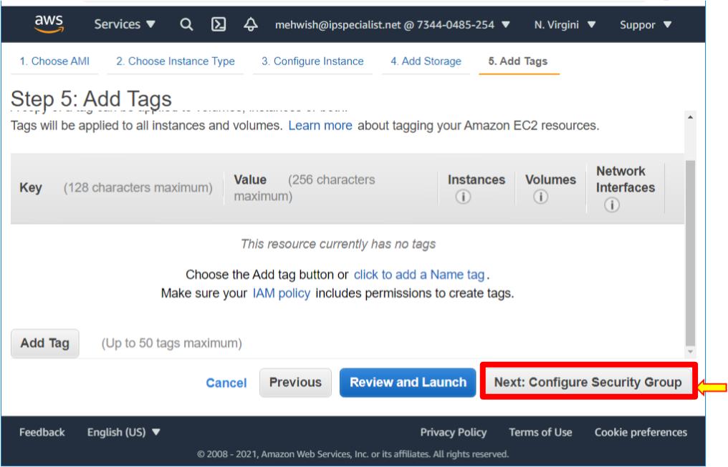

1. Next, configure the Security Group. A security group is like a virtual firewall around an EC2 instance. Create a new security group for the selected option, give the security group the name ‘IPS-holpubSG’, and give the description the same value. It allows SSH, and this is necessary for us to test access. Now notice the source. It essentially allows all IP addresses on the public internet to access your instance. For this lab, this setting is correct because this lab will be shut down. When you launch an EC2 instance, you do not want to leave it open to all IP addresses. It is recommended to set your security group rules to allow access for known IP addresses only. In this case, your IP address or the IP address range for a specific organization. You can add a description if you like, then Click ‘Review and launch’.

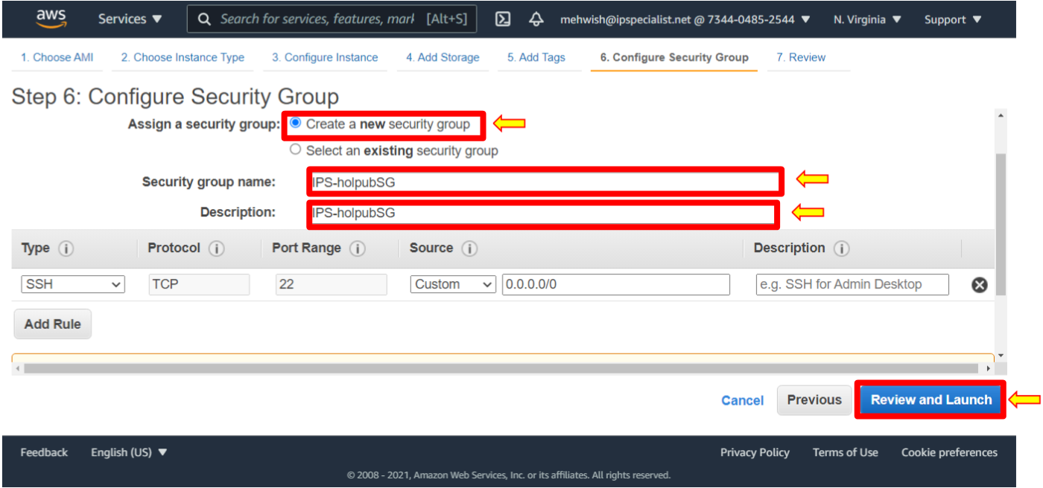

1. Again, this is just a notification that your security group allows anyone on the internet to access your EC2. You can go through the details, storage, and tags. When done, click ‘Launch’.

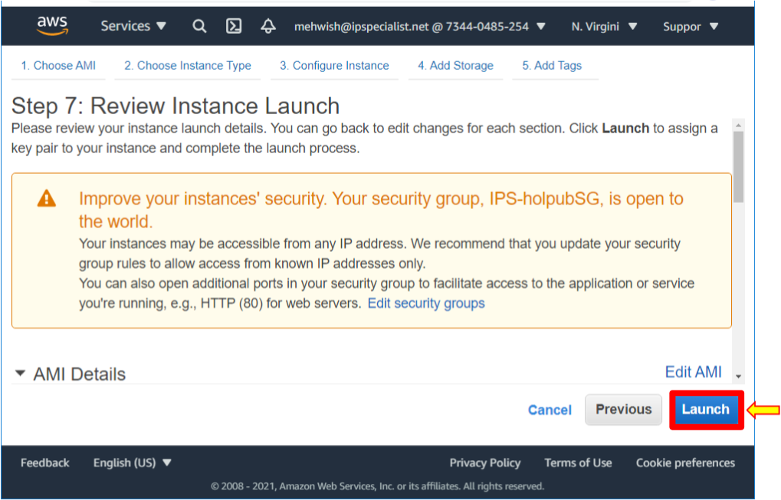

1. Now, this step here is very important. Create a new key pair and download that key pair. Doing this allows us to access our EC2 instance from our local machine. Create a new key pair and name it ‘IPS-holpubkeypair’, and then click ‘Download’ key pair. It is important to download the key pair because you will not have another opportunity to download it. Notice that it is downloaded into a ‘.PEM’ or PEM file in a secure and accessible location. Click ‘Launch Instances’.

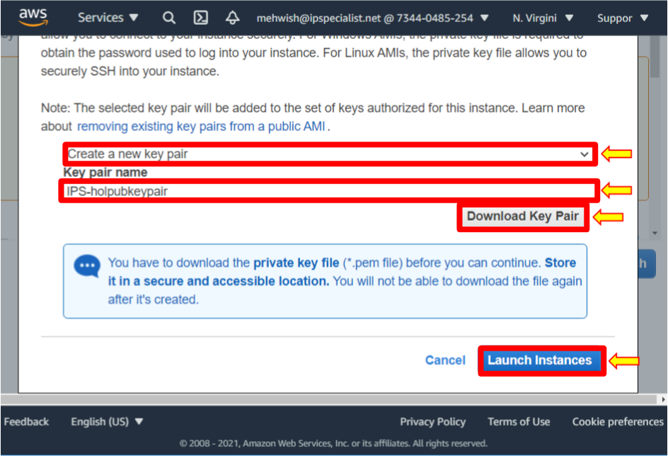

1. Click ‘View Instances’.

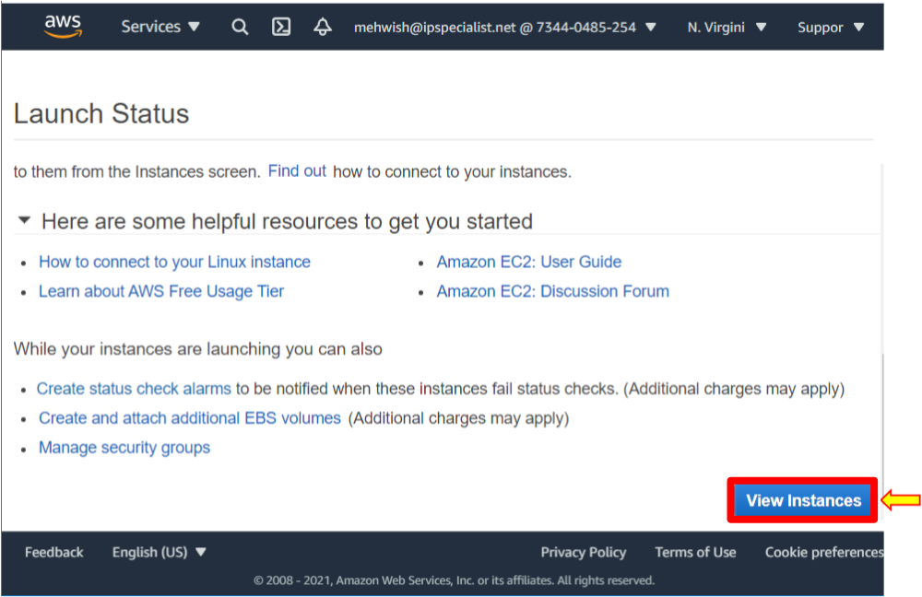

1. Notice here that the instance state is pending.
2. S0, while it is launching, go ahead and launch another EC2 instance. But this time, in the private subnet.

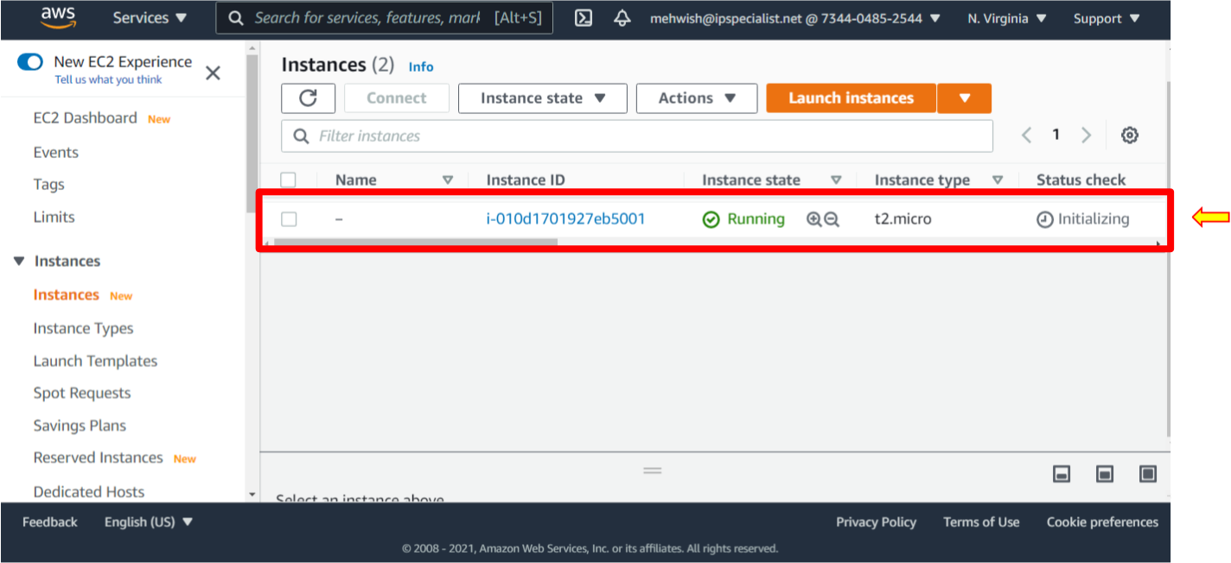

1. Click ‘Launch Instances’ and follow similar steps to what we previously did.
2. Select the ‘Amazon Linux 2 AMI 64-bit’.
3. Select the ‘T2 micro’ and click ‘Next: Configure Instance Details’.
4. Select the ‘IPS-sn-private-b’ subnet. For auto-assigned public IP, use the subnet settings. Notice here that the setting is disabled because this subnet should remain private. As we did before, click ‘Next: Add Storage.’

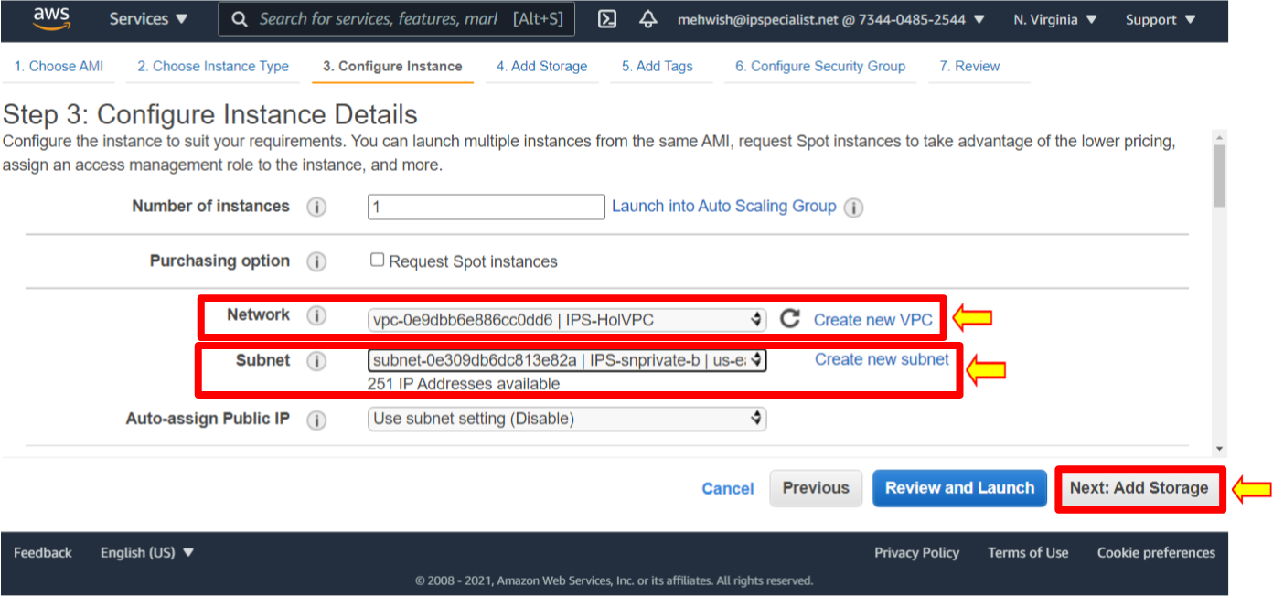

1. Click ‘Next: Add Tags’.
2. Next, we will configure the security group.
3. For the security group, first, create a new security group name, ‘IPS-holprivSG’ and add the same name in the “Description” section. Allow SSH coming from this IP address range. Now notice this is the IP address range ‘10.0.1.0/24’ associated with our public subnet. It means only resources are in the proper subnet IP range. Click Review and Launch, review it and then click Launch.

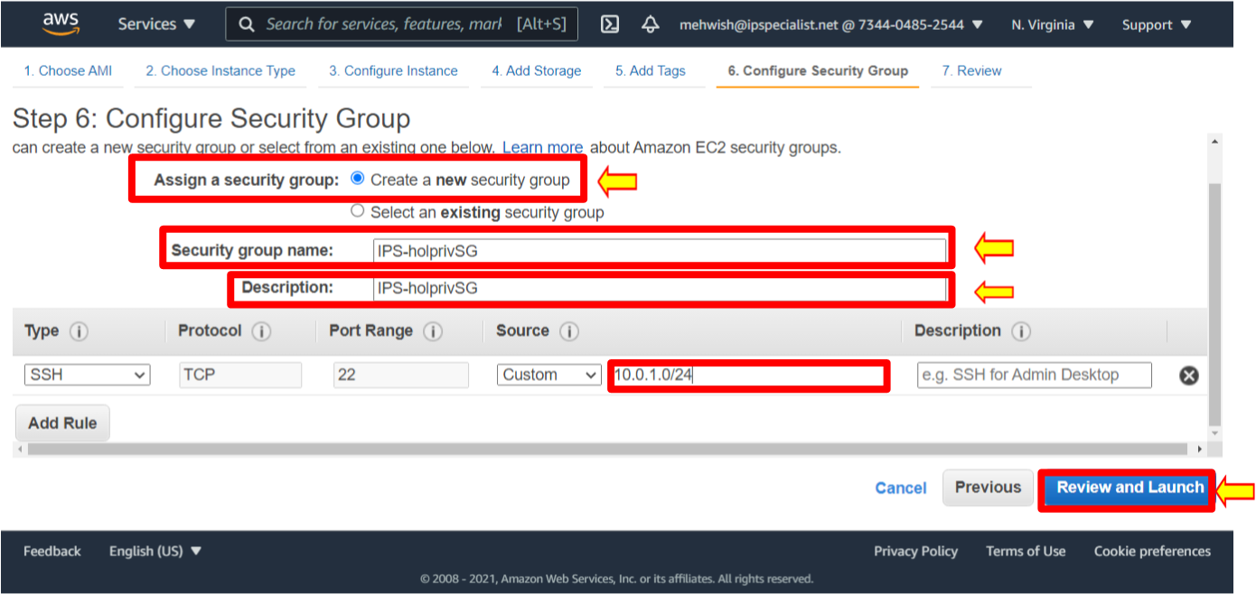

1. Create a new key pair, and instead of naming it the ‘IPS-holpubleypair’, name it ‘IPS-holprivkeypair1’. Download this key pair and launch instances.

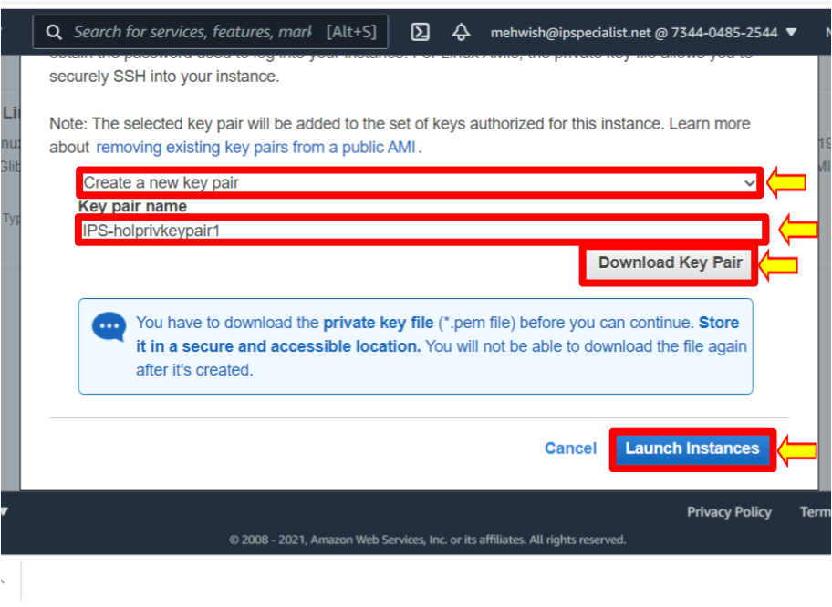

1. Click ‘View instances’.
2. Once the instance is up and running, copy the public IP address of the Public instance on a clipboard. You will need it in the future to log in to the instance.

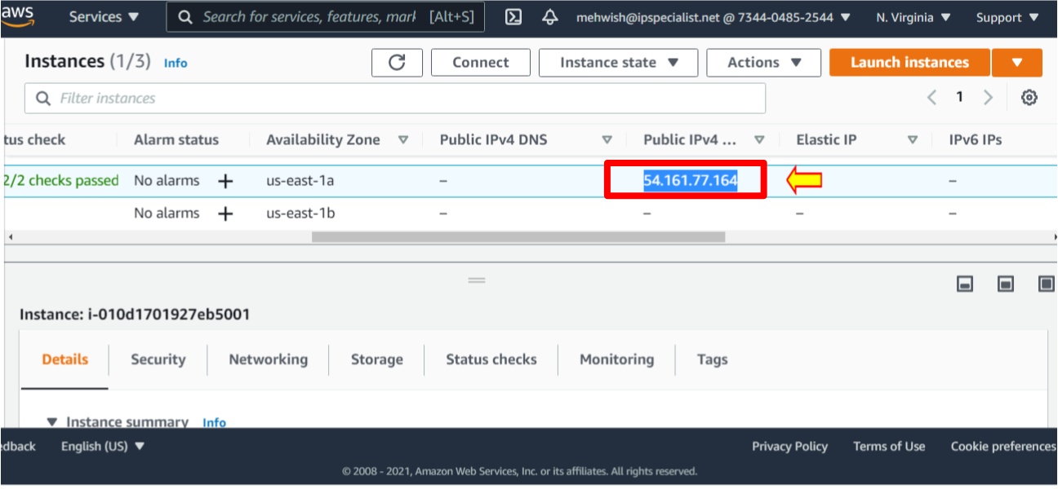

1. Using the key pair that you created, SSH into your EC2 instance. For the Mac platform, follow the instructions on the following link: https://docs.aws.amazon.com/quickstarts/latest/vmlaunch/step-2-connect-to-instance.html
2. On the Windows platform, open PuTTYgen.
3. Click ‘Load’ to load the existing private key file ‘IPS-holpubkeypair.pem’ you downloaded when creating the EC2 instance. With PuTTYgen, convert ‘.pem.’ file to ‘.ppk.’ file.

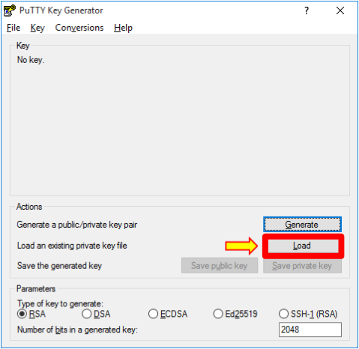

1. Navigate to the folder where your key is, select it, and click ‘Open’.

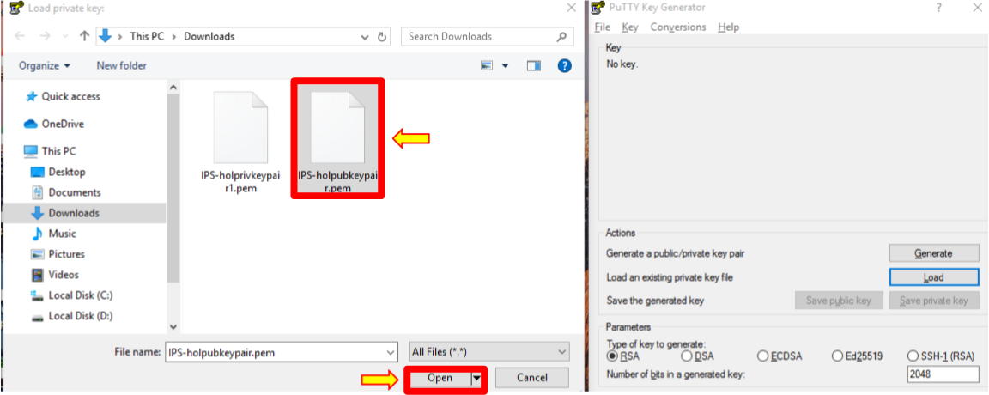



1. A dialogue box will be displayed saying, ‘Successfully imported foreign key’. Click ‘OK’.

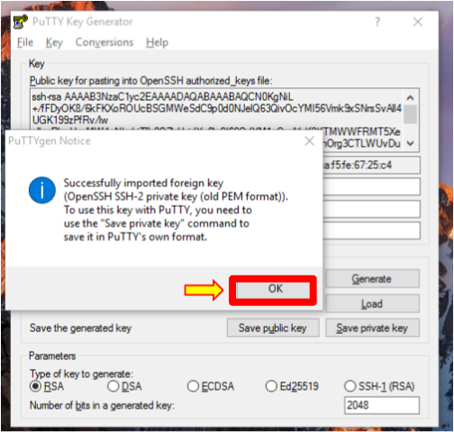

1. Next, you will need to save this private key. Select ‘Save private key’ and click ‘Yes’.

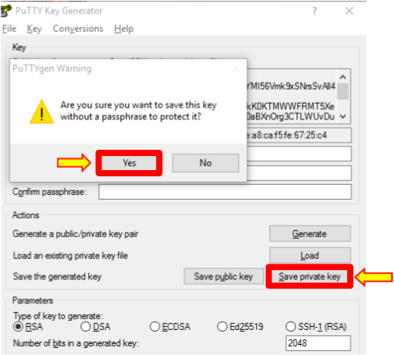

1. Enter the private key name and save it as ‘IPS-holpubkeypair.ppk’ file. Once you are done, close PuTTYgen and open PuTTY.

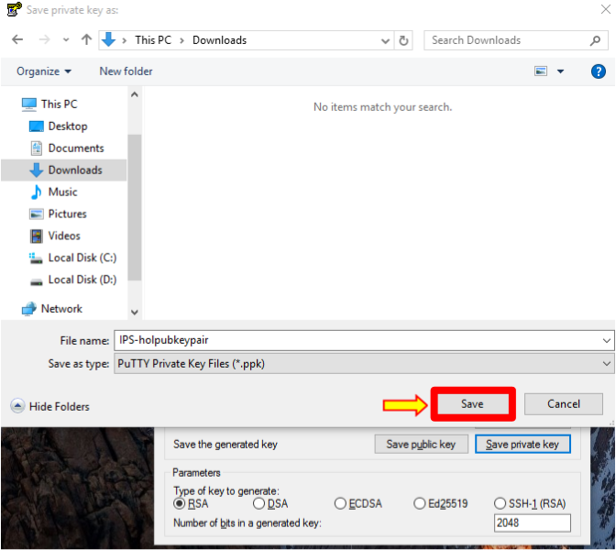

1. Navigate to SSH and then Auth from the left side of the Category pane.

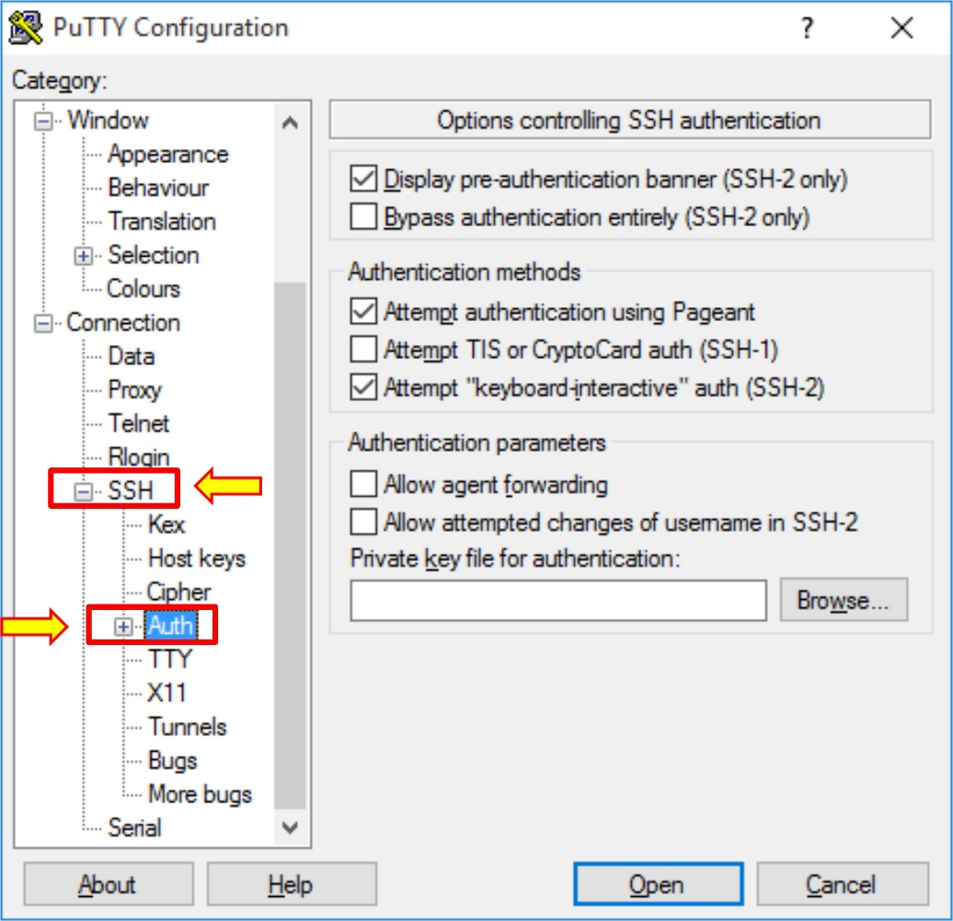

1. Click ‘Browse’ and navigate to the private key file ‘IPS-holpubleypair.ppk’.
2. Select the key ‘IPS-holpubkeypair.ppk’ and click ‘Open’. Now, navigate to ‘Session’ from the left side of the category pane.

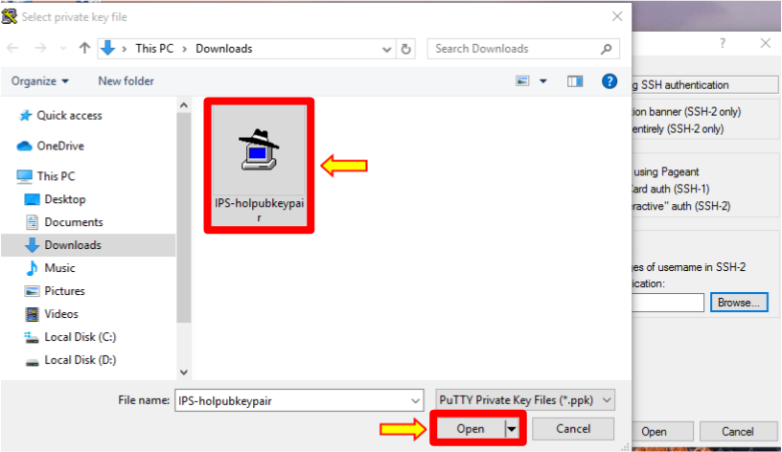

1. Copy the public IP address of the EC2 instance you previously saved in notepad and paste it into the ‘Host Name (or IP address)’ and ‘Saved Sessions’ fields. Click the ‘Save’ button, select the IP address, and click ‘Open’.

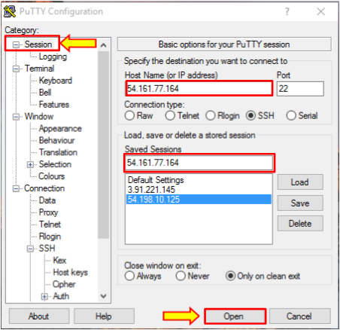

1. The ‘PuTTy Security Alert’ window will open. Click on ‘Yes’ to proceed further.

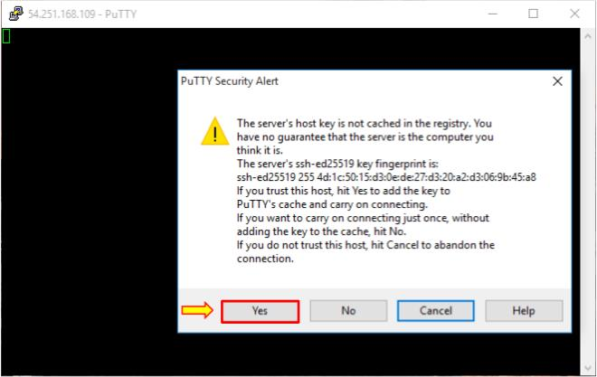

1. It may prompt you for a username, so type in ‘ec2-user’ and hit enter. You will be logged in to your public instance.

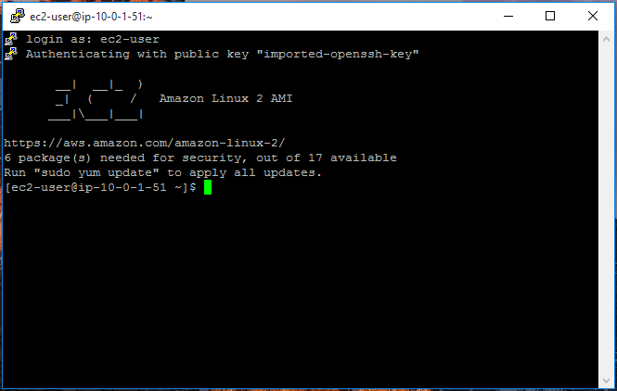

1. Now, let’s test the connection to the Private Instance.
2. You should be able to connect to your private instance within the same VPC.
3. Now, this is slightly tricky. Make sure you follow along.
4. Log into your public instance. To access your private instance, you need a key pair file. Remember to download that key pair file to your local machine.
5. To access your private instance, you must recreate that key pair file on this public EC2 instance.
6. Create a blank key pair file. Use VI editor to do that and thecal the same thing we called previously ‘IPS-holprivkeypair1.pem’.

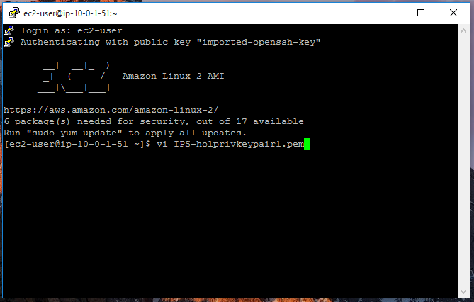

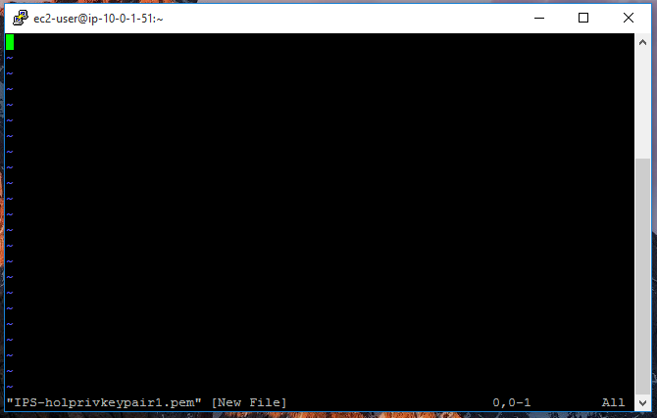

1. This is a blank file. To insert information into this file, press the lowercase ‘i’ on your keyboard. Notice that it is in ‘insert’ mode.

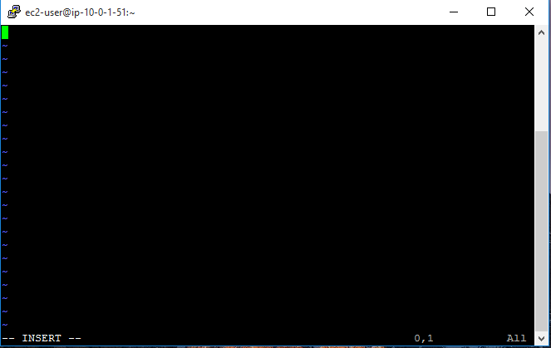

1. Now, go back and open the private key pair file in the text editor. Copy and paste all the content.

This is what the file looks like.

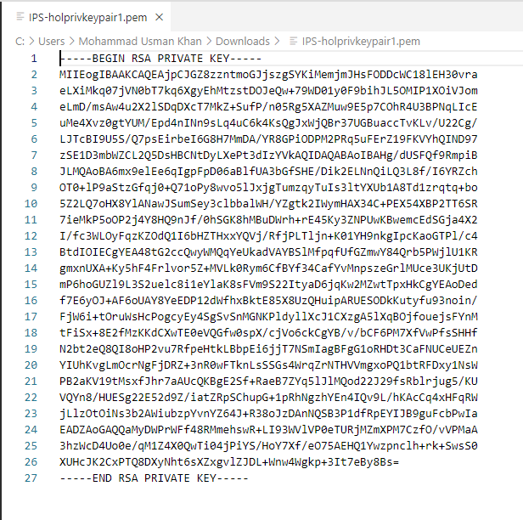

1. Copy everything in this file and paste it here.

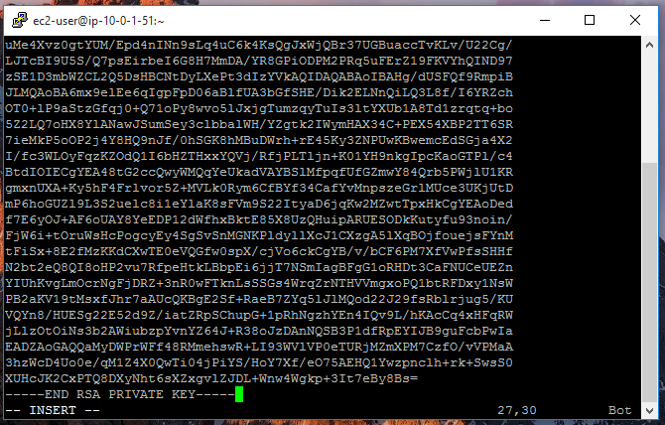

1. To get out from VI insert mode, press the ‘Esc’ key from your keyboard. Then type colon wq (:wq) and press enter.

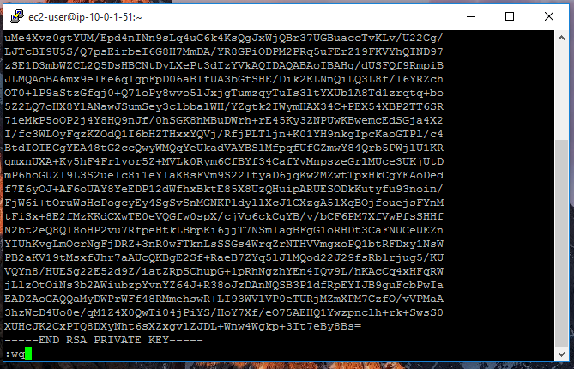

1. Created key pair file will be on our public EC2 instance.
2. Before setting the connection string for our private instance, it navigates back to the AWS Management Console.
3. After that, go to the private instance and click connect.

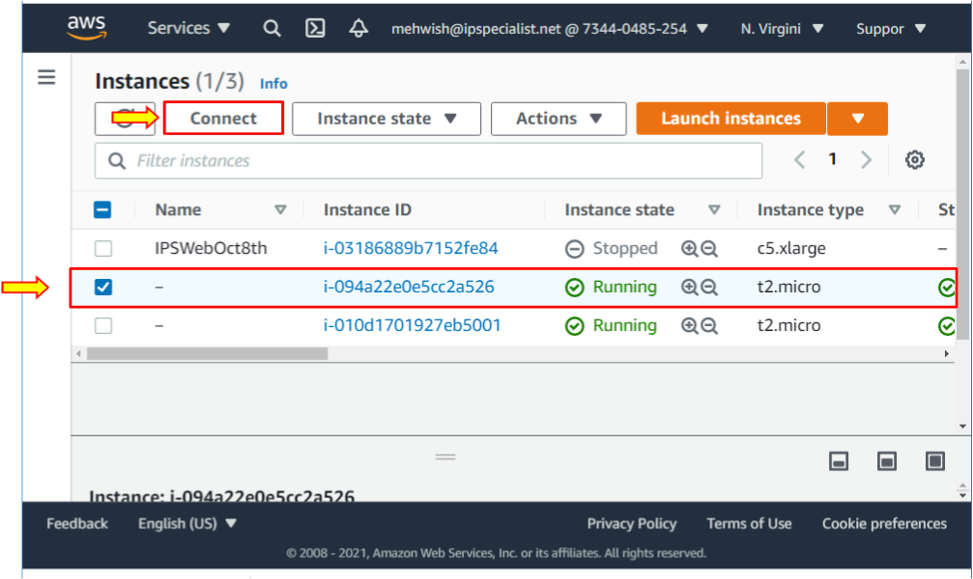

1. Using the SSH client, copy that connection string and then go back to my prompt and paste that connection string. Now, press enter.

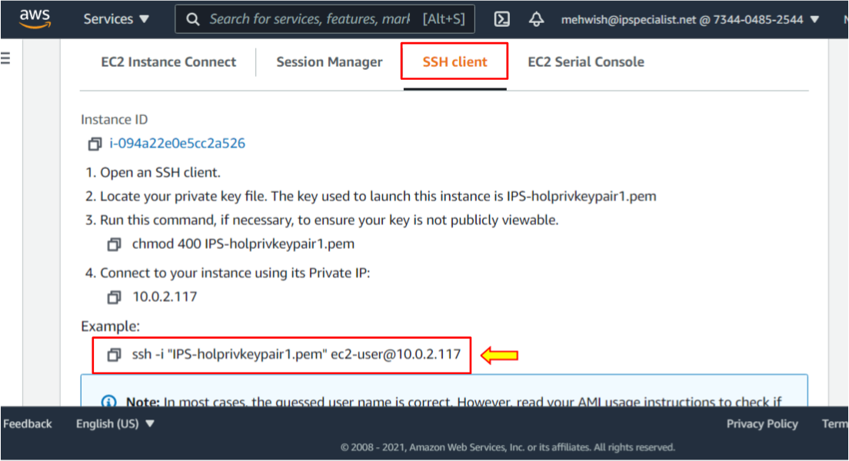

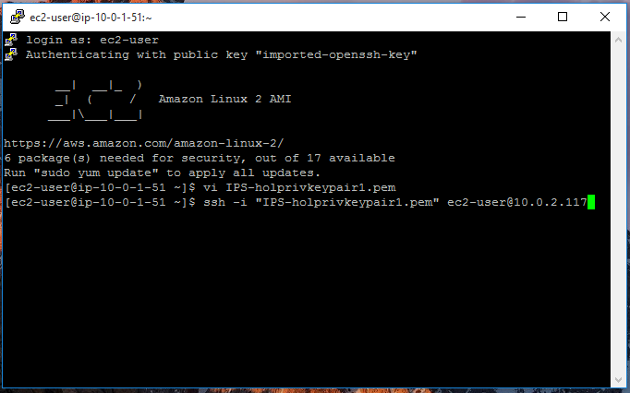

1. Type ‘Yes’. You will see an error message about an unprotected private key file, and this will happen if you forget to lock down the key pair file.

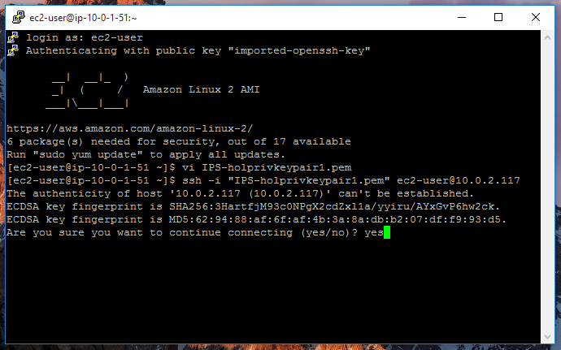

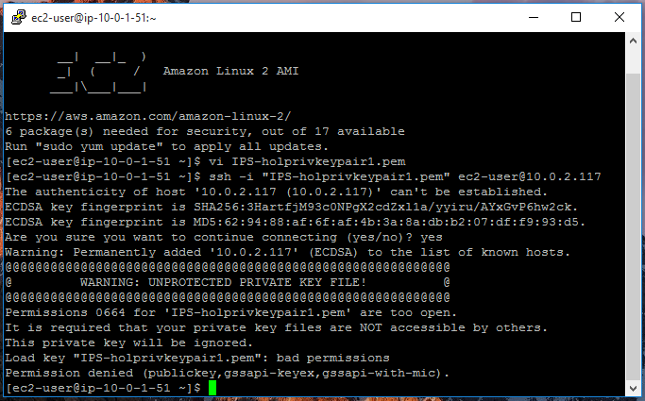

1. To change the permissions on this key pair file, type chmod 400 and the name of the file ‘IPS-holprivkeypair1.pem’. Press enter.
2. Now, that error should go away.

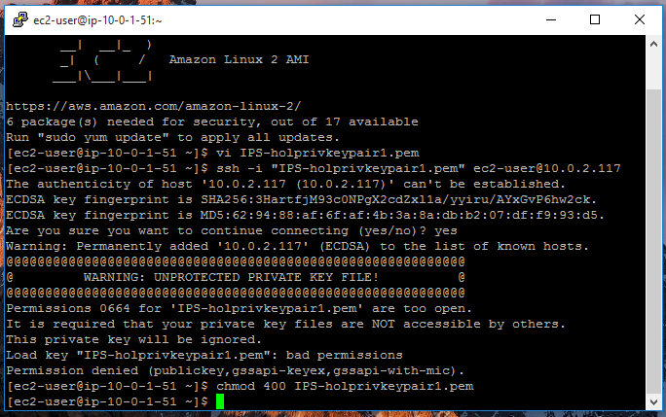

1. Now, pass your connection string and press enter.

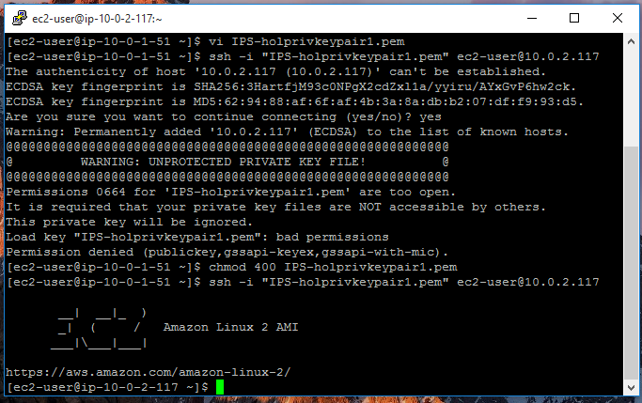

1. You have accessed the private instance from the public instance.

## Lab 3-11: Using a Load Balancer

### Lab Prerequisites

* Familiarity with basic AWS Cloud Computing concepts and terminology
* An AWS account with an active subscription

### Service Introduction

Application traffic is automatically distributed across different EC2 instances using Elastic Load Balancing (ELB). It smoothly offers the load balancing capacity needed for application traffic distribution, allowing you to reach higher levels of fault tolerance in your applications.

Elastic Load Balancing supports all Application Load Balancers, Network Load Balancers, and Classic Load Balancers. You can choose a load balancer based on the requirements of your application, and high availability, intelligent scaling, and robust security are all features of these load balancers.

For flexible application control and TLS termination, use an Application Load Balancer. Use the Network Load Balancer if your application requires high performance and a static IP address. If your application is developed on the EC2 Classic network, use the Classic Load Balancer.

### Case Study Enterprise Retail – Primooz

Background

Primooz was established in the year 2010 by a group of investors in the United Kingdom. The company started selling high-quality foods, medicines, beverages, and fashion products in the United Kingdom. It has grown to become one of the most popular UK online shopping stores, gaining goodwill from shoppers due to its memorable in-store experience.

Primooz offices, manufacturing plants, data centers, and employees are based in the following locations:

* **Head Office in London:** Approximately 100 employees are based at the head office involving strategy, marketing, finance, human resources, technology, and operations
* **Regional Offices:** 3 offices are in Manchester, Liverpool, and Leeds. Each office consists of 5 to 10 employees from Sales and Pre-Sales functions
* **Manufacturing Plants:** 2 Manufacturing plants are based in Liverpool and Shanghai, China
* **Data centers:** Primooz has only one data center in London with 20 x 42U rack space
* **Remote Workforce:** Around 50 sales representatives are hired across the UK to boost sales

***Business Challenge***

As we know, Primooz has developed a new web server to cope with customer demand. The portal is working well initially, but after some time, the portal is simultaneously accessed by many customers. So, only a single web server is responsible for processing the data. As the simultaneous traffic demand increases, the web server becomes overloaded. To overcome this problem, another web server has been added. Adding a second web server creates another problem: how traffic is shared between the two web servers. You are hired as a Cloud Engineer by Primooz to propose an appropriate solution for this issue.

Proposed Solution

As a Cloud Engineer, you have decided to deploy an Amazon Load balancer to distribute traffic evenly. You have proposed a solution by using a load balancer in front of two web servers to access the data before reaching the destination. Therefore, multiple users can access the portal more efficiently at a similar time.

The load balancer is generally used to distribute the traffic arriving on the front end to the backend pool as per rules and health status.

Lab Diagram

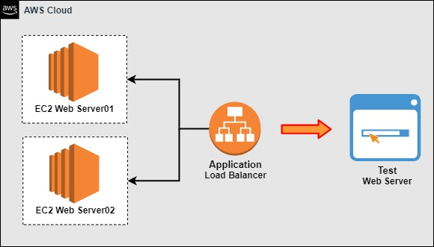

Figure 3-26: Load Balancer

Implementation Steps

1. Create the First Web Server.
2. Create the Second Web Server.
3. Create a Load Balancer.
4. Test out the Load Balancer.

### Solution

|  |  |
| --- | --- |
| **Step 1: Create the First Web Server**   1. Log in to the **AWS Console.** 2. Click **Services**.      1. Select **EC2** from **Compute**.      1. On the left-hand menu, click **Instances.**      1. Click **Launch instances**.      1. In **Step 1: Choose an Amazon Machine Image**, locate **Amazon Linux 2 AMI (HVM), SSD Volume Type**, check **64-bit (x86)**, and click **Select**.      1. In **Step 2: Choose an Instance Type**, select **t2.micro**, and click **Next: Configure Instance Details**.      1. Leave everything by **default**, and go to **Step 5: Add Tags**.   **Key** **Value**  Name Web server01  Department Development Team   1. Click on **Next: Configure Security Group**.      1. In **Step 6: Configure Security Group**, select **Create a new security group**. 2. Set the **Security group name** as **WebDMZ**. 3. Set the **Description** as **WebDMZ**. 4. Select **Add Rule**.   Type: **HTTP**  Protocol: **TCP**  Port Range: **80**  Source: Custom, **0.0.0.0**   1. Click **Review and Launch**.      1. Click **Launch**.      1. In the key pair dialog pop-up, select **Create a new key pair**. 2. Set the **Key pair name** as **WebPrivateKey**. 3. Click on the **Download** button.      1. Click **Launch Instances**.      1. Click **View Instances**.      1. Select **Running Instance**. 2. Copy the **public IP address** of the **EC2 instance** to log in through the AWS command line.      1. Open **PuTTYgen** to convert the **.pem** file into a **.ppk** file and save the private key. 2. Once you are done, close **PuTTYgen** and open **PuTTY**. 3. Navigate to **SSH** and then **Auth** from the left side of the Category pane. 4. Select the key private key and click **Open**. 5. Enter the **public IP address** of the EC2 instance **Host Name (or IP address)** and **Saved Sessions fields**. Click the **Save** button and click **Open**.      1. The **PuTTy Security Alert** window will **open**. Click on **Accept** to proceed further.      1. It may prompt you for a username, so type in **ec2-user** and hit enter. You will be logged in to your **Public Instance**. 2. Type in **sudo su** to get super-user access and **clear** the screen.      1. Type yum install httpd -y to install **Apache software** in the EC2 instance.      1. Once **Apache** is installed, you need to start the **Apache server**. 2. Type in service httpd start to start the **Apache server**.      1. Type **cd /var/www/html** to type in the landing page. 2. Run the **ls** command, and you will see that it is currently empty. 3. Once again, **clear** the screen.      1. Type **nano index.html** to open the html editor. 2. Then type **ls**.      1. Edit the landing page of your website as you want. 2. Then, click **Yes** to save the text.      1. Close the editor, and you will see the **index.html** is saved.      1. Open up your **browser** and test your **website**. 2. Enter the **public IP address** in the browser, and you should be able to see your webpage **index.html**.     **Step 2: Create the Second Web Server**   1. Click **Launch instances**.      1. In **Step 1: Choose an Amazon Machine Image**, locate **Amazon Linux 2 AMI (HVM), SSD Volume Type**, check **64-bit (x86)**, and click **Select**.      1. In **Step 2: Choose an Instance Type**, select **t2.micro**, and click **Next: Configure Instance Details**.      1. In **Step 3: Configure Instance Details**, enter the following details: 2. Set **Network** as **Default**. 3. Make sure you select a different availability zone for this instance. Your previous EC2 instance is in the availability zone **us-west-2c.** Therefore, select **us-west-2a** for this instance. 4. Scroll down to the **Advanced Details** section. 5. Enter the following code in **Advanced Details**: 6. After adding the **code**, click on **Next : Add Storage**   #!/bin/bash  yum update -y  yum install httpd -y  service httpd start  chkconfig on  cd /var/www/html  echo "<html><body><h1>Hello Shopping, This Is Web Server 2</h1></body></html>" > index.html     1. Leave everything by **default**, and go to **Step 5: Add Tags**.   **Key** **Value**  Name Web server02  Department Development Team   1. Click on **Next: Configure Security Group**.      1. In **Step 6: Configure Security Group**, select **Create a new security group**. 2. Set the **Security group name** as **WebDMZ**. 3. Set the **Description** as **WebDMZ**. 4. Select **Add Rule**.   Type: **HTTP**  Protocol: **TCP**  Port Range: **80**  Source: Custom, **0.0.0.0**   1. Click **Review and Launch**.      1. Click **Launch**.      1. In the key pair dialog pop-up, select **Choose an existing key pair**. 2. Select the **Key pair name** as **WebPrivateKey**. 3. Check the acknowledge statement. 4. Click on **Launch Instances**.      1. Click **View Instances**.      1. Select **Running Instance**. 2. Copy the **public IP address** of the **EC2 instance** to log in through the AWS command line.      1. Enter the **public IP address** in the browser, and you should be able to see your webpage **index.html**.     **Step 3: Create a Load Balancer**   1. Click on **Services**.      1. Select **EC2** from Compute. 2. Scroll down the left-hand pane and select **Load Balancers** under the **Load Balancing** tab.      1. Click **Create Load Balancer**.      1. Select the **type of load balancer**. 2. Click **Create** on the **Application Load Balancer**.      1. Enter a **name** for your load balancer as **WebLoadBalancer**. You will use this load balancer as **internet-facing**, and the address type is **IPv4.**      1. For the **Mappings**, select all the **availability zones** for the **load balancer**.      1. For **Security groups,** select **WebDMZ**.      1. For **Listener**, select **Protocol: HTTP** and **Port: 80**. 2. Select **Create target group**.      1. You will redirect to the **Create target group** page. 2. For **Choose a target type**, select **Instances**. 3. Enter a **Target group name** as **Web servers**.      1. In **Advance health check** **settings**, enter the following values:   **Port: *Traffic port***  **Healthy threshold: *3***  **Unhealthy threshold: *2***  **Timeout: *3***  **Interval: *5***  **Success codes: *200***   1. Click on the **Next** button.      1. In **Available instances**, select **Web server01** and **Web server02.** 2. Click on **Create target group**.      1. You will see the **Target group** as **WebServers** being added.      1. Click on **Create load balancer**.      1. The **load balancer** is now successfully **created**.     **Step 4: Test out the Load Balancer**   1. Now, both web servers are behind your load balancer. Click **Load Balancers** from under the **Load Balancing** tab.      1. Select the newly created Load balancer **WebLoadBalancer**. 2. Copy the **DNS name** and open it in your **browser**. | |
| 1. This DNS name now leads to one of the **Web servers** we just created.   s   1. Refresh the browser to see another **Web server**.      1. If you terminate one instance and then use the same DNS name, the load balancer will detect that one of the Web servers is down and **redirect** traffic to the other **Web server**. 2. Go back to the **EC2 instances** and **stop** one instance. 3. Select **Web server01** and **stop** this **instance**.      1. You will see the instance is now **shutting down**.      1. Go back to the browser and use the same **DNS name**. 2. This time it leads to the other Web server, as the **load balancer** detects that one is down and redirects to the active **Web server**. |

## Lab 3-12: Bastion Host

### Introduction

A bastion host, also known as a jump box or jump server, is a server that controls access to a private or internal network from the internet. Bastion hosts often run the absolute minimum number of services since they frequently reside on the Internet and want to minimize their attack surface. Additionally, they are frequently used to proxy and record communications, including SSH sessions.

### Problem

An organization has recently shifted its on-premises resource to Aws cloud. Alex, a security engineer, has been assigned the task of making a solution that provides secure remote access to the organization's network with sensitive and critical information. How would it be possible?

### Solution

Using the concept of Bastion host service offered by Aws, the above requirement can be achieved.

|  |
| --- |
| **Step 01: Creating Bastion Host**  1. Log in to AWS Management Console using your credentials.    2. From the search bar, search and open the EC2 instance.  3. The pane of EC2 will appear; click on **Launch instances.**    4. Now, write a name for your EC2 instance and add tags if you want.    5. Select **Ubuntu OS** for this instance.    6. Add key pair in .pem format.    7. Select t2.micro instance size.    8. Then, create a security group.    **Note:** Create a new security group and give it a suitable name, such as ssh-from-Internet, after which you should create SSH rules that only permit connections for your team.  9. Configure storage and add volume if you want.    10. Leave the remaining options as default and click on **Launch instance.**    11. From the instance page, you can verify the configured details.    **Step 02: Test Connectivity to the Bastion Server**  12. Open your instance and click on **Connect.**    13. Connect to the instance via SSH.    14. Read and apply the instructions to access your instance.    15. Login using the **sudo** command.    **Note:** You can change the bastion server name using **sudo nano /etc/hostname. Save the file using CTRL+S and quit using CTRL+X.**  **16. After that, return to the console, expand the Actions tab, choose Networking, and click on Change Security Group.**    16. Navigate to your recently created security group. Choose your security group and click on **Assign Security Groups.** |